Table of Contents

Module 1 7

Microscopy 7

Biochemistry: Important Advance 8

Genetic: Information Flow and inheritance 8

Carbon-containing molecules are stable 8

Bond Polarity 8

Water is cohesive: network of hydrogen-bonded molecules, hydrogen bond is weak compared to covalent bonds. 8

Selectively Permeable Membranes 9

Cellular membrane is a hydrophobic barrier 9

Membrane lipids Are Amphipathic 9

Membranes are Selectively Permeable 9

Module 2- Macromolecules of the cell 10

Proteins 10

Cell processes 10

Small molecules 10

Levels of organization in Protein structure 10

4 Protein major classes 11

The monomers are amino acids 11

The structure of 20 amino acids 11

The polymers are Polypeptides and Proteins 11

Peptide bond formation 12

Polypeptide and Proteins 12

Primary structure 12

Secondary structure 12

Categories of Proteins 12

Tertiary Structure 13

Quaternary structure 13

Disulfide Bond formation in Insulin 13

The Primary structure of Insulin 13

Structure of Hair 13

The roles of DNA and RNA in Protein synthesis 13

Nucleic Acids 13

Transcription and Translation 13

Nucleic Acids 13

The Monomers are Nucleotides 14

Polymers: DNA and RNA 14

A DNA molecule is double-stranded Helix 14

RNA Structure 15

The Phosphorylated Forms of Adenosine 15

Hydrogen Bonding in Nucleic Acid Structure 15

Polysaccharides 15

Polysaccharides 15

The Monomers are Monosaccharides 15

Polysaccharides 15

Polysaccharide Polymers are Storage and Structural 15

Glycogen (storage) 15

Starch (storage-plants) 16

Cellulose (structural polysaccharide) 16

Lipids 16

Fatty Acids Are the Building Blocks of several classes of Lipids 17

Triacylglycerol Are Storage Lipids 17

Phospholipids Are Important in Membrane Structure 17

Steroids Are Lipids with a Variety of Functions 17

Terpenes are Formed from Isoprene 17

Module 3 – Introduction to Cells and Organelles 18

Types of Cells and Their Properties 18

There Are Three Limitations on cell size 18

Eukaryote Cells use Organelles to compartmentalize Cellular Function 18

Chromosome 19

Genetic Information 19

The Eukaryotic Cell – Plasma Membrane, Organelles, And the Endosymbiont Theory 19

Mitochondrion 19

The Chloroplast 19

The nucleus is the information center of the Eukaryotic cell 19

The Endoplasmic Reticulum 20

The Golgi Complex 20

Cell Vesicles, Structural Components, and Examples of Cellular Invaders 20

Ribosome 21

Cytoplasm 21

Cytoskeleton 21

Microtubules 22

Microfilaments 22

ECM and Cell Wall Are “Outside” the cell 22

The ECM 22

Vacuoles 22

Secretory Vesicles 22

Lysosome 23

The Phagolysosome 23

Peroxisome 23

Hydrogen Peroxide 23

Viruses 23

Bacteriophage 23

Module 4 -Enzymes 23

Enzyme Structure 23

Factors Affecting enzymes 24

Module 5 - Membranes and the Endomembrane System 24

Membrane Characteristics and Composition 24

The functions of the membrane 24

Membranes are sites of specific proteins and functions 24

Regulation of Transport across the cell is a main function of membrane protein 25

Membrane Proteins Mediate Cell Adhesion and Cell-to-Cell Communication 25

Membrane proteins play role in other cell functions 25

Membrane Structure: Fluid Mosaic Model 25

Three classes of membrane proteins 25

Main class of membrane lipids: phospholipids, glycolipids and sterols 25

Phospholipids 25

Glycolipids 25

Cerebrosides 25

Gangliosides 25

Sterols 26

Membrane Asymmetry: most lipids are distributed unequally between two monolayers 26

Lipids move freely within their monolayer 26

Membrane fluidity is measured using fluorescence recovery after photobleaching (FRAP). 26

Membrane functions properly only in the fluid state 26

Membranes Functions and the Endomembrane System 26

Effects of Sterol on Membrane Fluidity 26

**Lipid rafts** localized regions involved in cell signaling 27

Function of the lipid rafts 27

Receptors in lipid rafts 27

The membrane consists of a mosaic of proteins: evidence from Freeze-Fracture Microscopy 27

Membrane Proteins are Oriented Asymmetrically Across the Lipid Bilayer 27

DNA Sequencing 27

The Endomembrane System 28

Membrane biosynthesis 28

Variations in amount of Rough and Smooth ER 28

The Golgi Complex 28

Roles of the ER and Golgi Complex in Protein Trafficking 28

Protein and Lipid Tags 28

Exocytosis and Endocytosis: Transporting Material Across the Plasma Membrane 28

Phagocytosi 28

Receptor-Mediated Endocytosis 29

Process of receptor-mediated endocytosis 29

Module 6 – Membrane Transport 29

Transport Across Membranes: Overcoming the Permeability Barrier. 29

Cell Transport 29

Simple diffusion: unassisted movement down the gradient. 29

Osmosis of water across membrane 29

Second Law of Thermodynamics 30

Solute size 30

Solute Polarity 30

Ion permeability 30

Rate of simple diffusion directly proportional to concentration gradient 30

Facilitated diffusion: protein-mediated movement down the gradient 31

Carrier and channel proteins facilitate transport by different mechanisms 31

Glucose transporter: a uniport carrier 31

Active transport: protein-mediated movement up the gradient. 31

Pumps 31

Na+/K+ pump 32

Module 8 - DNA, Chromosomes, the Nucleus 32

Information and DNA 32

DNA 32

DNA in the genome 33

Restriction Enzymes 33

The Nucleus 33

Module 9 – Signal Transduction 33

Receptor-Ligand Interactions 33

Signal Transduction Mechanisms 33

Different Types of Chemical Signals Can Be Received by Cells 33

Receptor Binding Involves Specific Interactions Between Ligands and Their Receptor 34

Receptor-ligand interactions 34

Receptor Affinity 34

Coreceptors 34

Receptor Down-regulation 34

Agonist and Antagonists 34

Receptor Binding activates a sequence of signal transduction events within the cell 34

Signal Amplification 35

GPCRs And Second Messengers 35

Categories of Receptors 35

G Protein-Linked Receptors 35

The structure and regulation of G protein-linked receptors 35

The structure, activation, and inactivation of G proteins 35

Regulation of G protein-linked receptors 35

G protein Inactivation 36

Cyclic AMP is a second messenger whose production is regulated by some G proteins. 36

G proteins are active for only a short period of time 36

Many G Proteins use inositol trisphosphate (IP3) and Diacylglycerol (DAG) as second messenger 36

Calcium in signaling 36

Protein Kinase-associated receptors 36

Protein Kinase-associated receptors 36

Growth factors often bind protein kinase-associated receptors 36

Receptor tyrosine kinases aggregate and undergo autophosphorylation 37

The activation of receptor tyrosine kinases 37

Dominant negative mutant receptors are important tools for studying receptor function 37

Constitutive mutations 37

Disruptions of growth factor signaling can lead to cancer 37

Hormone signaling 38

Hormones can be classified by the distance they travel and by their chemical properties 38

Chemical classification of endocrine hormones 38

Control of Glucose metabolism is a good example of endocrine regulation 38

Intracellular effects of adrenergic hormonal control of glycogen degradation 38

Insulin signaling acts through PI 3-kinase to regulate resting glucose levels 38

Diabetes 39

Steroid hormone receptors act primarily in the nucleus, not the cell surface 39

Module 10 – Recombinant Technology 39

DNA technology 39

The PCR Revolution 39

PCR 39

DNA Extraction 39

Copying DNA 40

Technologies And Utilities 40

Historical Perspective 40

Basic Principles 40

Major technologies 40

Principal uses of chips 40

DNA chips 40

DNA chip design 41

cDNA (complementary DNA) fragments arrays on nylon and glass 41

Scanning the arrays 41

The Affymetrix approach 41

Module 11 – Cell Cycle, Mitosis and DNA Replication 42

Mitosis and the Cell Cycle 42

The Cell Cycle, DNA Replication and Mitosis 42

Overview of the cell cycle 42

Mitosis is a relatively short part of the cell cycle 42

Chromosomes in Mitosis 42

Mitosis is subdivided into Prophase, Prometaphase, Metaphase, Anaphase and Telophase 42

Prophase 43

Centromere 43

Kinetochores 43

Metaphase 43

Anaphase 43

Telophase 44

The mitotic spindle is responsible for chromosome movements during mitosis 44

Spindle Assembly and Chromosome Attachment 44

Spindle Assembly 44

So what Drives Chromosomes Movement 44

Cytokinesis Divides the Cytoplasm 44

Myosin and cleavage 44

Cell Division is Sometimes Asymmetric 45

DNA Replication 45

DNA Replication 45

DNA Replication is usually bidirectional 45

Eukaryotic DNA Replication involves multiple replicons 45

Replication licensing ensures that DNA molecules are duplicated only once prior to each cell division 46

DNA polymerase catalyze the elongation of DNA chains 46

Biotechnology functions of DNA polymerases 46

DNA is synthesized as discontinuous segments that are joined together by DNA ligase**s** 46

Proofreading is performed by the 3’->5’ Exonuclease activity of DNA polymerase 46

DNA synthesis requires RNA primers 46

The process of DNA synthesis 46

Unwinding the DNA double helix requires DNA helicases, Topoisomerases, and single-strand DNA binding proteins 47

Summary: DNA Replication 47

Telomeres solve the DNA end-replication problem 47

Telomeres and telomerase 47

Most cells have a limited life span 47

DNA damage and repair 47

DNA damage can occur spontaneously or in response to mutagens 48

**Translesion synthesis** and excision repair correct mutations involving abnormal nucleotides 48

Progression through the cell cycle is controlled at several key transition points 48

Checkpoint pathways monitor chromosome-to-spindle attachments, completion of DNA replication, and DNA damage 49

Checkpoints 49

Apoptosis 50

Necrosis 50

Apoptosis is triggered by death signals or withdrawal of survival factors 50

Damaged cells can trigger their own apoptosis 50

Module 12 – Regulation of Gene Expression 51

The Regulation of Gene Expression 51

Gene regulation 51

Catabolic and anabolic pathways utilize different strategies for adaptive enzyme synthesis 51

Catabolic pathways and substrate induction 51

Anabolic pathways and end product repression 51

Anabolic pathways and end product repression 51

Lac repressor is an allosteric protein whose binding to DNA is controlled by lactose 52

Genetic repression 52

Effector Molecules 52

Genes involved in lactose catabolism are organized into an inducible operon 52

The lac operon 52

Repressor protein 53

Reversible interaction of the lac repressor 53

The genes involved in tryptophan synthesis are organized into a repressible operon 54

Eukaryotic gene expression is regulated at multiple levels 54

Module 13 – Gene Expression 55

Transcription and Translation 55

The central dogma of molecular biology 55

Transcription in Eukaryotes and Prokaryotes 56

Bacterial Transcription 56

Transcription involves 4 stages: binding, initiation, elongation, and termination 56

Eukaryotic transcription 57

Gene expression: protein synthesis and sorting 57

Translation: key players 57

The ribosome carries out polypeptide synthesis 58

Ribosome structure 58

Ribosomes: antibiotic targets – selective toxicity 58

Transfer RNA molecules bring amino acids to the ribosome 58

tRNAs 59

Aminoacyl-tRNA synthetases link amino acids to the correct transfer RNAs 60

Amynoacyl-tRNA synthesis 60

Messenger RNA brings polypeptide coding information to the ribosome 61

Eukaryotic mRNAs are monocistronic 61

Protein factors are required for the initiation, elongation, and termination of polypeptide chains 62

Initiation of translation in prokaryotes 62

Eukaryotic initiation 63

Chain elongation involves sequential cycles of aminoacyl tRNA binding, peptide bond formation, and translocation 63

Termination of polypeptide synthesis is triggered by release factors that recognize stop codons 64

Polypeptide folding is facilitated by molecular chaperones 65

Molecular chaperones 65

A summary of translation 65

Mutations and translation 65

Suppressor tRNA overcomes the effects of some mutations 66

Post-translational processing and genetic engineering tools 66

Posttranslational processing 66

Translation is mainly cytosolic 67

Protein targeting and sorting 67

Cotranslational import 67

The signal hypothesis 67

Protein folding and quality control take place within the ER 68

Proteins release into the ER lumen are routed to the Golgi complex, secretory vesicles, lysosomes, or back to the ER 68

Soluble proteins 68

Post-translational import allows some polypeptides to enter organelles after they have been synthesized 68

CRISPR/CAS9- What is it and how does it work? 68

CRISPR/Cas9 – How is it used as a tool? 68

Homologous end joining for gene insertion 68

How gene drives could change the world 68

Summary 68

# Module 1

## Microscopy

* Light microscope: resolution: 1 μm.
* Smaller limit of resolution of a microscope, the greater its **resolving power**.
* Phase contrast/differential interference contrast microscopy exploits differences in the phase of light passing through a structure with a refractive index different than the surrounding medium, shows images in 3-D.
* **Fluorescent microcopy**: detects fluorescent dyes to how location of substances in the cell.
* **Confocal scanning**: uses a laser beam to illuminate a single plane of a fluorescently labeled specimen (3-D reconstruction).
* **The electron microscope**: uses an electron beam rather than light – limit of resolution: 0.1-0.2nm- magnification 100,000X than light microscope.
* **TEM**: transmission electron microscopy. Electrons are transmitted through the specimen.
* **SEM**: scanning electron microscopy. The surface of a specimen is scanned by a beam of electrons deflected from specimen ‘surface.

## Biochemistry: Important Advance

* **Chromatography**: techniques used for sample preparation which let separate molecules by size, charge or binding affinity.
* **Electrophoresis**: the cell is loaded into a gel and then an electric field is applied to the gel. This Electric field moves the molecules through the gel differentially
* Since DNA molecules are negatively charged, when the electric field is applied to the gel, the DNA molecules moved towards the positive charges. But larger molecules move slowly and run through the argos matrix and run next to a sample of known molecular weight called the DNA ladder. Uses an electrical field to move proteins, DNA or RNA molecules through a medium based on size/charge.
* **Mass spectrometry or MassSpec**: determine size and composition of protein by measuring mass to charge ratio of ions in a sample.

## Genetic: Information Flow and inheritance

* Humans have 23 pairs of chromosomes.
* Uses **ultracentrifugation** and **electrophoresis** to separate DNA and RNA molecule.
* **Recombinant DNA technology**, restriction enzymes cut DNA at specific places to create recombinant DNA molecules with DNA from different sources.
* **DNA sequencing**: methods to determine base sequences of DNA molecules.
* Possible to sequence entire genome (entire DNA content of a cell).
* **Cell membrane**: a barrier which maintains physical integrity.
* **Covalent bonds**: sharing of a pair of electrons between 2 atoms.

## Carbon-containing molecules are stable

* Valence: Carbon (4), Nitrogen (3), Oxygen (2) and Hydrogen (1).
* Stability is expressed as bond energy.
* Bond energy is expressed as cal/mol, amount of energy required to break one mole (6 x 1023) of bonds.
* A calorie is the required energy to increase the T of 1g of water by 10C.

## Bond Polarity

Polar bond result from a high electronegativity (affinity for electrons) of O2 and sulfur compared to carbon and hydrogen.

Water molecules are polar: electrons drawn by oxygen, partial negative charge at the end of O2, a partial positive charge around hydrogen molecules, bent shape.

## **Water is cohesive**: network of hydrogen-bonded molecules, hydrogen bond is weak compared to covalent bonds.

* Combined effect of many hydrogen bonds accounts for water’s high
  + **Surface tension**: vast number of hydrogen bonds.
  + **Specific heat** gives water its T stabilizing capacity.

Specific heat: amount of heat a substance must absorb to raise its T by 10C.

Specific heat of water: 1 cal per gram.

* + **Boiling point**.
  + **Heat of vaporization**.
* Water changes temperature very slowly.
* Water is an excellent solvent: due to its polarity. Most of the molecule in cells are also polar, and so can form hydrogen or ionic bonds with water.
* Takes part in many chemical reactions.

## Selectively Permeable Membranes

A barrier such

* Impermeable to much of the cell contents.
* Insoluble in water.
* Permeable to water.

## Cellular membrane is a hydrophobic barrier

* Consists of: **phospholipids**, **glycolipids**, **membrane proteins, and sterols:** cholesterol(animal), ergosterols (fungi) and phytosterol (plants).

## Membrane lipids Are Amphipathic

* **Phospholipid** have a polar head, due to negatively charged phosphate group linked to a positively charged group (serine, choline, ethanolamine), and two non-polar hydrocarbon tails.
* A Membrane is a lipid bilayer with Proteins embedded within it
* Polar heads of membrane phospholipids face outward toward aqueous environment.
* Hydrophilic tails are oriented inward.

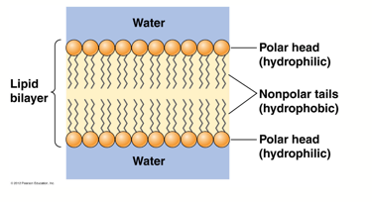

## Membranes are Selectively Permeable

* Cellular constituents are mostly polar or charged and are prevented from entering or leaving the cell.
* Because of the hydrophobic interior, impermeable to most polar molecules and very impermeable to ions.
* Non-polar and very small molecules diffuse.
* The rate at which a molecule diffuse across lipid bilayer depends on its size and solubility.

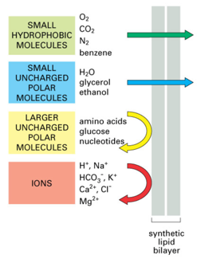

# Module 2- Macromolecules of the cell

4 major classes of macromolecules:

* Nucleic Acids
* Proteins
* Polysaccharides
* Lipids

## Proteins

### Cell processes

**Transcription** takes DNA and makes RNA out of it. Nature makes an RNA copy of DNA and by post-transcription makes mRNA out of it. **Translation** is the process where small molecules are added to the mRNA to build up first **polypeptides**, amino-acids in small repeat units. Then there is a process to convert polypeptides into a protein: post-translation. And when it takes a 3D shape it takes protein activity to effect particular functions like an effector molecule and then activate more functions.

### Small molecules

* **Amino acid**: monomeric components of proteins.
* **Aromatic bases** (purines and pyrimidines): components of nucleic acids: DNA and RNA.
* **Sugars** (monosaccharides):
  + **Ribose**: components of nucleic acids
  + **Glucose**: used in metabolism to make energy
* **Lipids**: components of phospholipids.

### Levels of organization in Protein structure

* **Primary**: Amino acid sequence based on covalent peptide bonds.
* **Secondary**: fold alpha-helix, beta-sheet or random coil based on hydrogen bonds.
* **Tertiary**: 3D folding of a single polypeptide chain based on hydrogen bonds, disulfide bonds, electrostatic interactions and hydrophobic effect.
* **Quaternary** (macromolecule): association of two or more polypeptides with same interactions seen in tertiary structure.

### 4 Protein major classes

* enzymes, (**catalysts**) that greatly increase rates of chemical reactions in cells.
* **Structural proteins**: provide support and shape to cells and organelles, giving cells their characteristic appearances.
* **Motility proteins**: play key roles in the contraction and movement of cells and intracellular structures.
* **Regulatory proteins**: are responsible for control and coordination of cellular functions, ensuring that cellular activities are regulated to meet cellular needs.
* **Mono-functional proteins**: have a single function: catalytic, structural, motility, or regulatory.
* **Bi-functional proteins** plays two different roles.

### The monomers are amino acids

* Proteins are linear polymers of amino acids.
* 60 different kinds of amino acids, but only 20 are used in protein synthesis.
* **Every amino acid has the basic structure with a carbonyl group, an amino group, a hydrogen atom, and a R-group all attached to a single carbon atom.**
* The R group determines the characteristics (size, polarity and pH) for each type of amino acid.
* Amino acids such as **valine, methionine, and alanine** are nonpolar (hydrophobic), while amino acids such as **serine, threonine, and cysteine** are polar (hydrophilic). The R groups of lysine and arginine are positively charged so these amino acids are also known as basic (high pH) amino acids. Proline is an exception to the standard structure of an amino acid because its R group is linked to the amino group, forming a ring-like structure.
* Except for glycine, for which the R group is a hydrogen atom, all amino acids have at least one asymmetric carbon atom. Therefore, most amino acids exist in two isomeric forms, L and D-amino acids.

### The structure of 20 amino acids

* **Group A**: hydrophobic and nonpolar R groups.
* **Group B**: hydrophilic and polar R group, uncharged.
* **Group C**: hydrophilic, polar R group, and protonated or ionized at cellular pH.

### The polymers are Polypeptides and Proteins

* Stepwise addition of new amino acid to a growing chain of amino acids by **a dehydration (condensation) reaction**: formation of polymers and water molecule.
* The reaction could be reversed by adding back water molecules; used by cells to excrete water waste.
* -H and -OR groups are removed as water comes out and the covalent bond between the carboxyl group and an amino group is called **peptide bond**.

### Peptide bond formation

Always an N-terminus at one end and C-terminus at the other end.

### Polypeptide and Proteins

* Product of amino acid polymerization is a polypeptide (polymers of peptides).
* Protein is a polypeptide or polypeptides that have folded properly, combined with other additional components needed for proper functioning, and is now functional.
* Protein is a polypeptide chain that have attained a unique stable, 3-D shape and it is biologically stable.
* Monomeric protein consists in a single polypeptide vs. multimeric proteins, two polypeptides: a dimer, 3 polypeptides: a trimer.
* **Ribonuclease** is a monomeric protein.
* Hemoglobin is a multimeric protein. It contains 4 polypeptides, (2 alpha-subunit and 2 beta-subunits), alpha-chains and beta-chains.
* Each subunit contains a **heme group** with an iron atom. Each heme iron can bind a single oxygen molecule.
* **Homomeric**, and **heteromeric**: protein made up at least of two different polypeptides chains.
* Protein structure is determined by its amino acid sequence which drives the folding and intramolecular bonding of the linear amino acid chain, which ultimately determines the protein's unique three-dimensional shape.

### Primary structure

* Primary structure is the amino acid sequence of the constituent polypeptides.
* Amino acids are always written from **the N-terminal** to the **C-terminal**, direction in which the polypeptide is synthesized.
* Once incorporated into a polypeptide chain, individual amino acids are called **amino acid residues**.
* **Disulfide bond**: very stable bond between two sulfur atoms of 2 cysteine amino acid residues.

### Secondary structure

Because of the folding groups of amino acids are close to each other.

The group interactions result in two structural patterns: the alpha-helix and beta sheet conformations.

### Categories of Proteins

* **Fibrous proteins**: have extensive secondary structure (either a helix or beta sheet) giving them a highly ordered and repetitive structure.
* **Globular proteins**: most of the proteins.
  + The polypeptide chain is folded in a compact structure. It is folded locally into alpha-helical or Beta-sheet structures. These regions are folded on one another to give the protein its compact, globular shape.
  + The folding is possible because the interspersed random coils allowing the polypeptide to loop and fold.
  + Have unique tertiary structures
  + They consist of a number of segments called domains. A **domain** is a discrete, locally folded unit of tertiary structure. A domain typically contains 50-350 amino acids, and usually has a specific function.

### Tertiary Structure

3-D folding of a single polypeptide chain.

### Quaternary structure

* Level of organization concerned with subunit interactions and assembly.
* Association of 2 or more polypeptides to form a multimeric protein.
* Applied only to multimeric proteins.
* The bonds and forces that maintain quaternary structure are the same as those responsible for tertiary structure: **hydrogen bonds, electrostatic interactions, hydrophobic interactions, and covalent disulfide bonds**.

### Disulfide Bond formation in Insulin

It could be reversed.

### The Primary structure of Insulin

Insulin consists of two polypeptides, A and B chains. The two chains are covalently linked by two inter-chain disulfide bonds.

### Structure of Hair

**Alpha keratin protein**: 3 helices of alpha-keratin wrap into protofibrils which then bond together to form microfibrils. Microfibril= 9 + 2 protofibril based structure. Microfibrils aggregate to form macrofibrils.

### The roles of DNA and RNA in Protein synthesis

**mRNA**: directs amino acids sequence of polypeptides.

**tRNA**: binds to amino acids and directs them to proper locations within the growing polypeptide chain.

**rRNA**: components of the ribosomes that serve as the site of protein synthesis.

## Nucleic Acids

### Transcription and Translation

* **Transcription**: DNA molecule is transcribed into an RNA molecule.
* **Translation**: takes RNA and converts into protein.

### Nucleic Acids

* Nucleic acids are macromolecules critical in the storage, transmission and expression of genetic information.
* Are linear polymers of nucleotides, strung together in a genetically determined order.
* Two major types are DNA and RNA.
* DNA contains the sugar deoxyribose, RNA contains 5-carbon sugar ribose in each of its nucleotides.
* DNA plays as the repository of genetic information, whereas RNA molecules play several different roles in the expression of that information during protein synthesis.
* **mRNA**: directs amino acids sequence of polypeptides that is during polypeptide synthesis.
* **tRNA**: binds to amino acids and directs them to proper locations within the growing polypeptide chain.
* **rRNA**: components of the ribosomes that serve as the site of protein synthesis.

### The Monomers are Nucleotides

* Nucleic acids are informational macromolecules that contain non-identical monomeric units in a specified sequence.
* The monomeric units of nucleic acids are called **nucleotides**.
* DNA and RNA each contain only four different kinds of nucleotides.
* Each nucleotide consists of **a five-carbon sugar, a phosphate group, and a nitrogen-containing aromatic base. The sugar is either D-ribose (for RNA) or D-deoxyribose (for DNA).**
* **The phosphate is joined by a phosphoester bond to the 5' carbon of the sugar (-P-O-C-), and the base is attached at the 1' carbon. The base maybe either a purine or a pyrimidine.**
* DNA contains the **purines**: **adenine** (A) and **guanine** (G) and the **pyrimidines**: **cytosine** (C) and **thymine** (T). RNA also has **adenine**, **guanine**, and **cytosine** but contains the pyrimidine **uracil** (U) in place of thymine.
* ATP is the energy-rich compound used to drive a variety of reactions in the cell, including the activation of monomers for polymer formation.
* Nucleotides plays two roles in the cell:
  + Monomeric units of nucleic acids
  + Serve as intermediates in various energy transferring reactions.

### Polymers: DNA and RNA

* Nucleic acids are linear polymers formed by linking each nucleotide to the next through a phosphate group.
* The result of a condensation reaction with the -H and -OH groups come off from the sugar and the phosphate group respectively is **a 3’,5’ phosphodiester bond**.
* Incoming nucleotides must be added in a specific, genetically determined sequence. The **template to specify nucleotide order is DNA for both DNA and RNA synthesis.**
* **Purines: Adenine, Guanine**
* **Pyrimidines: Thymine, Uracil, Cytosine**
* Purine and pyrimidine bases have carbonyl groups and nitrogen atoms capable of hydrogen bonds formation under appropriate conditions.
* Paring of A with T (or U) and G with C

### A DNA molecule is double-stranded Helix

* The double helix consists in two complementary chains of DNA twisted together around a common axis to form a right-handed helical structure.
* The two chains are oriented in opposite directions along the helix, one in 5’3’ direction and the other in 3’-5’ direction.
* The sugar phosphate backbones of the two strands could be envisioned as the sides of a circular staircase where each step corresponds to a pair of bases held in place by hydrogen bonding.
* The right-handed helix is an idealized version of the B-DNA, the main form of DNA.
* Z-DNA is a left-handed double helix, with a longer, thinner sugar phosphate backbone.

### RNA Structure

* Secondary and tertiary structures are well understood only for tRNA molecules.
* **A nucleotide is composed of three components, namely a nitrogenous base, phosphate group, and sugar. A nucleoside is composed of two components, namely a nitrogenous base and sugar.** This is the basic difference between a nucleotide and a nucleoside.

### The Phosphorylated Forms of Adenosine

* Adenosine occurs as the free nucleoside, the monophosphate (AMP), the diphosphate (ADP), and the triphosphate (ATP).
* The bond that links the first phosphate to the ribose of adenosine is a low-energy **phosphoester** bond, whereas the bonds that link the second and third phosphate groups to the molecule are higher-energy **phosphoanhydride** bonds.

### Hydrogen Bonding in Nucleic Acid Structure

A-T pair held together by two hydrogen bonds, whereas the C-G pair has three hydrogen bonds.

## Polysaccharides

### Polysaccharides

* No known informational role in the cell.
* They are the storage polysaccharides **starch** and **glycogen** and the structural polysaccharide **cellulose**.
* Each of these polymers contains the 6-carbon sugar, **glucose** and its single repeat unit.

### The Monomers are Monosaccharides

* The repeats are single sugar called monosaccharides.
* A sugar can be an aldehyde or ketone that has two or more hydroxyl groups.
* 2 categories of sugars: **aldosugars**, with a terminal carbonyl group and the **ketosugars**, with an internal carbonyl group.
* Sugars are classified as triose (3 carbons), a tetrose (4), a pentose (5), a hexose (6), or a heptose (7).
* Most common: aldhohexose D-glucose, C6H12O6.

### Polysaccharides

Glucose also occurs in disaccharides consisting of 2 monosaccharide units linked covalently.

* **Maltose**: 2 glucose units linked together.
* **Lactose**: glucose linked to a galactose.
* **Sucrose**: glucose linked to a fructose.

### Polysaccharide Polymers are Storage and Structural

* Polysaccharides perform either storage or structural functions in cells. The most familiar storage polysaccharides are the starch of plant cells and the glycogen of animal cells. Both of these polymers consist of alpha-d-glucose units linked together by a **glycosidic** bond.
* Glycosidic bond: covalent bond between a carbohydrate (sugar) with its hydroxyl group (OH: either in alpha or beta configuration).

### Glycogen (storage)

* Glycogen is highly branched, with linkages occurring every 8 to 10 glucose units along the backbone and giving rise to short side chains of about 8 to 12 glucose units.
* Glycogen is stored mainly in the liver and in muscle tissue.  
  In the liver it is used as a source of glucose to maintain blood sugar levels, whereas in muscle it serves as a fuel source to generate the ATP needed for muscle contraction.

### Starch (storage-plants)

* Starch occurs both as un-branched amylose and as branched amylopectin.
* Like glycogen, **amylopectin** has a (1 -> 6) branches along the backbone and give rise to longer chains.
* Starch deposits are about 10-30% amylose and 70-90% amylopectin.

### Cellulose (structural polysaccharide)

* Cellulose is an important polymer quantitatively; more than half of the carbon in higher plants is present in cellulose.
* Like starch and glycogen, cellulose is also a polymer of glucose, but the repeating monomer is **beta-d-glucose** and the linkage is therefore beta (1 -> 4).
* Cellulose forms rigid, linear rods. These aggregate into **microfibrils**.
* Plant and fungal cell walls consist of these rigid microfibrils of cellulose embedded in a **non-cellulosic matrix**.
* Mammals do not possess an enzyme that utilize cellulose as food (cannot cleave glycosidic bonds).

**Polysaccharides are also important macromolecules in cell structure and function. How are they similar to proteins and nucleic acids, and how do they differ?**

* Made of repeating monomers: amino acids for proteins, nucleotides for nucleic acids, monosaccharides for sugars.
* A monomer joins with another monomer with the release of water molecules, leading to the formation of a covalent bond: hydrogen of one monomer combines with hydroxyl group of another monomer (dehydration synthesis), it requires energy. The reverse reaction is hydrolysis. Each macromolecule is broken down by a specific enzyme:
  + Proteins by enzymes pepsin and peptidase, and by hydrochloric acid
  + Lipids by lipase
  + Carbohydrates by amylase, sucrase, lactase or maltase.
* Storage or structural role based on type of glycosidic bonds.

## Lipids

* The distinguished feature of lipids is their **hydrophobic nature**.
* They resemble one another more in their soluble properties than in their chemical structures.
* **Not the result of stepwise polymerization found for proteins, nucleic acids, and polysaccharides.**
* Rich in nonpolar hydrocarbon regions and have relatively few polar groups.
* Some lipids are amphipathic having both a polar and a nonpolar region.
* They play at least 3 main roles in the cell:
* Energy storage
* Membrane structure
* Transmission of chemical signals into and within cells.
* The six main classes of lipids are **fatty acids, triacylglycerols, phospholipids, glycolipids, steroids, and terpene**s.

### Fatty Acids Are the Building Blocks of several classes of Lipids

* A fatty acid is a long, unbranched hydrocarbon chain with a carboxyl group at one end.
* It is amphipathic; the carboxyl group renders one end (“head”) polar whereas the hydrocarbon, “tail” is nonpolar.
* Fatty acid yields a great deal of energy upon oxidation.
* **Fatty acids without double bonds are saturated fatty acids: every carbon atom in the chain has the maximum number of hydrogen atoms attached to it.**
* **Unsaturated fatty acids contain one or a few double bonds.**
* General formula: n carbon atoms is **CnH2nO2**.

### Triacylglycerol Are Storage Lipids

* Triacylglycerols (triglycerides) consist of a glycerol molecule with 3 fatty acids linked to it.
* Glycerol is 3-carbon alcohol with a hydroxyl group on each carbon.
* Fatty acids are linked to glycerol by ester bonds, formed by the removal of water.
* Triglycerides are synthesized stepwise, with one fatty acid added at a time.
* Monoglycerides contain a single esterified fatty acid, diglycerides have 2, triglycerides have 3.
* Triglycerides are usually solid or semi-solid at room temperature and are called fats.
* In plants, mots triglycerides are liquid at room temperature – vegetable oils.

### Phospholipids Are Important in Membrane Structure

* Critical to the bilayer structure found in all membranes.
* Phospholipids are phosphoglycerides or sphingolipids.

### Steroids Are Lipids with a Variety of Functions

* Are derivatives of a 4-membered ring compound called phenanthrenes which makes them structurally distinct from other lipids.
* Only property that links to other classes of lipids: relatively nonpolar and therefore hydrophobic.
* **Cholesterol** is an amphipathic molecule, with a polar head group and a nonpolar hydrocarbon body and tail.
* **Cholesterol** found primarily in membranes.
* **Cholesterol** is the starting point for the synthesis of all the steroid hormones, which include the male and female sex hormones, the glucocorticoids and mineralocorticoids.

### Terpenes are Formed from Isoprene

**Terpenes**, synthesized from 5-carbon compound isoprene, also called isoprenoids.

Isoprene and its derivatives are joined together in various combinations to produce vitamin A1, carotenoid pigments.

**Lipids, our final class of macromolecules, are quite different from the other three classes, yet have some similarities. Explain.**

* **Fatty acids**
* **Phospholipids**: phosphoglycerides and sphingolipids
* **Glycolipids**

Considered as macromolecules due to their high molecular weight and their frequent association with macromolecules, particularly proteins. Lipids vary substantially in chemical structure but are grouped together because they share the common property of being hydrophobic and thus are nearly insoluble in water.

* Lipids are not polymers.
* Fatty acids are lipids consisting of a long hydrocarbon chain of 12–20 carbon atoms with a carboxylic acid group at one end.
* Phosphoglycerides and sphingolipids are types of phospholipids that make up the lipid bilayer of biological membranes. They are amphipathic molecules with two hydrophobic fatty acid chains and a polar phosphate-containing head group.
* **Glycolipids** are similar to phospholipids but contain a polar carbohydrate group instead of phosphate. They are often found on the outer surface of membranes, where they play a role in cell recognition.
* Other important cellular lipids are the steroids (including cholesterol and steroid hormones) and the terpenes (including vitamin A and some important coenzymes).

# Module 3 – Introduction to Cells and Organelles

## Types of Cells and Their Properties

* The main distinction between two cell types (Prokaryotes vs. Eukaryotes) is the membrane bound nucleus of eukaryotic cells.
* Prokaryotic cells can be divided into **bacteria** and **archaea**.
* Most bacteria and archaea surrounded by an extra-cellular structure: **cell wall**.
* Bacterial cell walls consist of **peptidoglycan**.
* Phylogenetic Tree of Life: ancestral cell -> bacteria, Archaea, Eukarya.
* Gram’s stain: staining to distinguish bacteria:
  + **Gram-positive** microorganisms have higher peptidoglycan content, whereas gram-negative organisms have higher lipid content.

### There Are Three Limitations on cell size

* *Need to maintain adequate surface are to volume ratio*

Cells that are specialized for absorption have characteristics to maximize surface area/volume.

* *Diffusion rates of Molecules*

Eukaryotic cells avoid the problem of slow diffusion rates by using carrier proteins or vesicles.

* *The Need for adequate local concentration of essential substances*

The larger the cell is, the more difficult to maintain these higher concentrations required for different type of reactions to occur.

### Eukaryote Cells use Organelles to compartmentalize Cellular Function

* As cell size increases, the number of molecules increase proportionately with volume.

The challenges of diffusing macro-molecules across the cell or accumulating higher concentrations in certain regions of cells can be mitigated by eukaryote cell development of organelles.

### Chromosome

DNA is tightly packed into gene and chromosome and contained in the nucleus.

### Genetic Information

* Eukaryotic cells replicate DNA and then distribute their chromosomes into daughter cells by **mitosis and meiosis, followed by cytokinesis, division of the cytoplasm**
* Bacterial and archaeal cells replicate their DNA and divide by binary fission.
* In the process of binary fission, an organism duplicates its genetic material, or deoxyribonucleic acid (DNA), and then divides into two parts (cytokinesis), with each new organism receiving one copy of DNA.

<https://biologydictionary.net/difference-binary-fission-mitosis/>

## The Eukaryotic Cell – Plasma Membrane, Organelles, And the Endosymbiont Theory

* A typical eukaryotic cell has: a **plasma membrane**, a **nucleus**, a membrane bounded **organelle**, and the **cytosol** supported by a **cytoskeleton**.
* The Plasma Membrane defines cell boundaries and retains content.
* Membrane proteins are also amphipathic, with oligosaccharides attached to them: **glycoproteins**.
* Plasma membrane is selectively permeable membrane: only certain compounds can move across this membrane, tight control of transport across in either direction for the cell.

### Mitochondrion

* Site of aerobic respiration.
* Oxidation of sugars and other fuel molecules extract energy from food and stores it as ATP.
* Most molecules for mitochondrial functions, are localized on the **cristae** or the matrix.
* Tissues with high demand for ATP have many mitochondria, located within the cell at the site of greatest energy needs (e.g., sperm and muscle cells).
* We inherit mitochondrial DNA (mtDNA) only from our mothers.

### The Chloroplast

* Site of photosynthesis in plants and algae.
* Large and quite be numerous.
* Like mitochondrion, contain own ribosomes, and a small circular DNA molecule.

### The nucleus is the information center of the Eukaryotic cell

* The nuclear envelope has numerous pores controlled by various proteins constituting a **nuclear pore complex**.
* The nucleus includes the **nucleolus**, the site of ribosomal RNA synthesis and ribosome assembly.
* The **endosymbiont theory**: mitochondria and chloroplasts and bacteria are similar; it suggests that mitochondria and chloroplasts originated from prokaryotes.
* Similarities:
* Circular DNA molecules without associated histone.
* rRNA sequences
* ribosome size
* sensitivities to inhibitors of RNA and protein synthesis.
* Type of proteins used in protein synthesis.
* Surrounded by double membranes
* Inner membrane has bacterial-type lipids

### The Endoplasmic Reticulum

* **Cisternae**: is the lumen; tubular membranes and flattened sacs.
* **Lumen:** internal space of ER.
* **Rough ER**:
  + Rough ER studded with ribosomes on cytoplasmic side.
  + free ribosomes not associated with rough ER.
  + Secretory and membrane proteins are made by ribosomes on rough ER.
  + Proteins intended to be used within the cytosol or for import into organelles are made on free ribosomes.
* **Smooth ER**:
  + No role in protein synthesis.
  + Involved in synthesis of lipids and steroids (cholesterol and its derivatives).
  + Responsible for inactivating and detoxifying substances.
  + Carbohydrate metabolism
  + Calcium storage
* **Sarcoplasmic reticulum** has critical functions in contraction.

### The Golgi Complex

* Consists in small number of flattened cisternae.
* At the **cis face**, transition vesicles from the ER fuse with the cis-Golgi network (CGN). At the **trans face**, transport vesicles bud from the trans-Golgi network (TGN) and carry lipids and proteins to other components of the endomembrane system.
* Two models for movement through the Golgi: **stationary cisternae model**: shuttle vesicles carry material from ER though successive Golgi compartments, **cisternae maturation model**: cisternae gradually change in composition as themselves move forward. In both models, enzymes and lipids needed in earlier compartments move backward in retrograde movement.
* Packaging station or the *post office*; processing and packaging secretory proteins and involved in complex polysaccharide synthesis.
* Role of sending off proteins to distant locations within the cells through vesicles.
* Accepts vesicles that bud off of the ER.
* The contents of vesicles from the ER are modified and processed in the Golgi complex.
* Secretory and membrane proteins are mainly **glycosylated** (addition of short-chain carbohydrates).

## Cell Vesicles, Structural Components, and Examples of Cellular Invaders

**Endomembrane system**: ER, Golgi, secretory vesicles and lysosomes.

The cytoplasm contains the cytosol and cytoskeleton

### Ribosome

* Ribosomes read or translate mRNA to link amino acids together and form proteins.
* Very small, can only be seen under microscope electronic.
* Small sedimentation coefficients.
* Sedimentation coefficient: is a measure of how rapidly the particle sediments when subjected to centrifugation.

### Cytoplasm

* Interior of the cell not occupied by the nucleus.
* Cytosol is the semifluid substance in which organelles are suspended.
* Cytosol is permeated by the cytoskeleton.
* Synthesis of fats and proteins and initial step of releasing energy from sugars take place in the cytosol.

### Cytoskeleton

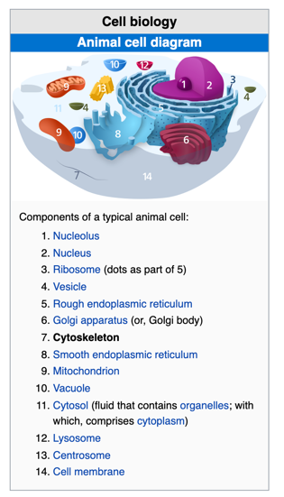

* The **cytoskeleton** is a 3-D array of interconnected **microfilaments**, **microtubules**, and **intermediate filaments**.
* Gives cell its definitive shape and internal organization.
* Plays also a role in cell movement and cell division.
* Serves as a framework for positioning and moving organelles, and macromolecules within the cell.

### Microtubules

* Are critical to mitosis.
* They form the **mitotic spindle fibers** that separate chromosomes prior to cell division.
* Play a role in the organization of the cytoplasm: overall shape, organelle organization, movement of macromolecules, distribution of microfilaments.
* Cylinders of longitudinal arrays of **protofilaments** with a hollow center called a **lumen**.
* Each protofilament is a linear polymer of **tubulin** with polarity.
* **Tubulin** is a dimeric protein (alpha-tubulin and beta-tubulin).

### Microfilaments

* Smallest components of the cytoskeleton.
* Form connections with plasma membrane to give structure and affect movement.
* But also help to move cell in specific way during cell division.
* Are polymers of the protein **actin**.
* Actin is synthesized as a monomer called **G-actin**.
* Subunits are polymerized into **F-actin**.
* Have a polarity.

### ECM and Cell Wall Are “Outside” the cell

* For plant and fungal cells, cells walls consist in cellulose microfibrils.
* Bacterial cell walls are composed of **peptidoglycans**, long chains of GlcNAc and MurNAc
* These are held together by peptide bonds between a small number of amino acids, forming a netlike structure.

### The ECM

* Support role
* In animal cells: a network of **proteoglycans** surrounds **collagen** fibers.
* Regulate processes:
  + Cell motility and migration.
  + Cell division.
  + Cell recognition and adhesion.
  + Cell differentiation during embryonic development.

### Vacuoles

* Membrane containers for temporary storage and movement of compound.
* Plant vacuole large to keep the plant upright.

### Secretory Vesicles

* After being processed by the Golgi complex, materials are exported from the cell into secretory vesicles.
* They move to the plasma membrane and fuse with it, releasing their content outside the cell.
* **Endomembrane system of the cell: ER, Golgi, secretory vesicles and lysosomes.**

### Lysosome

* Single membrane organelles that store **hydrolases**, enzymes that can digest any biological molecules.
* A special carbohydrate coating on the inner lysosome membrane protects it from digestion.
* All of the lysosomal enzymes are **acid hydrolases**, are active at low pH, but not at higher pH (7.2), pH of the inner cell.

### The Phagolysosome

* **Phagocytosis**: ingestion of bacteria by phagocytes.
* **Phagolysosome**: merge of phagosomes with lysosomes to destroy bacterial pathogens.

### Peroxisome

* Similar to lysosome but contains peroxide.
* Helps to break down fatty acids.

### Hydrogen Peroxide

* H2O2 highly toxic to cells but can be formed into water and oxygen by the enzyme **catalase**.
* These reactions are confined to peroxisomes that contain **catalase**, so that cells are protected from the harmful effects of peroxide.
* Peroxide production is increased during cellular stress (infection, disease, UV exposure) and can serve as a useful biomarker for early infections.

### Viruses

* Small.
* Invade and infect cells, using synthetic machinery to produce more viruses’ particles.
* No cytoplasm, organelles, or ribosomes and consist of only a few different molecules of nucleic acid and protein.
* Consist of a coat (capsid) or protein surrounding a core, containing DNA or RNA.
* Viruses that infect bacteria are **bacteriophages** or **phages**.  
  Each virus has a characteristic shape, defined by its protein capsid.
* Some viral capsids consist of a single type of protein, while more complex viruses have capsids with a number of different proteins
* Some viruses are surrounded by a membrane, and are called **enveloped viruses**: HIV.

### Bacteriophage

* In theory, bacteriophage exist for every type of bacterium.
* Present in every ecosystem.
* Can be highly specific for their hosts.

# Module 4 -Enzymes

## Enzyme Structure

* Catalysts lower the temperature which a chemical reaction occurs and make it easier to happen.
* All reactions occur at 98.6 degrees F.
* An extremophile is an organism that thrives in extreme environments.
* Activation Energy = Transition state energy – Reactant state energy
* With enzyme, we drop the activation energy.
* In the reaction sequence with catalyst, number of molecules increases for same amount of time and energy.
* The substrate of an enzyme are the **reactants** that are activated by the enzyme.
* Enzymes are specific to their substrates.
* Specificity is determined by the active site.
* The **shape** and the chemical environment inside the **active site** permit a chemical reaction to proceed more easily. Active site is where the reaction happens converting reactants to products.
* Substrate molecules coming, are bound to the enzyme surface in just the right orientation and shape, electronic substrate bonding happens with the chemical environment, pulls the molecules apart to form the product.

## Factors Affecting enzymes

* **Substrate concentration**: more enzymes, more reactions.
* **pH**: most of enzymes react at cellular pH.
* **Temperature:** specific T at which enzyme works.
* **Inhibitor**: can slow down the rate of the chemical reaction, even can stop the enzyme to function.
* Denature of the enzyme: pull off water molecules from the enzyme.
* Enzyme substrate complex: when the substrate locks into the enzyme.
* At the end the enzyme can go back at the reactance side of the reaction coordinate diagram: **reversibility**.
* More material present, the more reaction takes place as long there is enough reactant present.
* Reaction velocity does not increase beyond **Vmax**.

# Module 5 - Membranes and the Endomembrane System

## Membrane Characteristics and Composition

### The functions of the membrane

* Serves as a permeability barrier between the cell and outside environment.
* Localizes and organizes different functions within the cell.
* Facilitates transport of different molecules within the cell between organelles and also its outside environment: nutrients, ions or water, and wastes.
* Helps the cell to perceive its external environment and respond appropriately thru receptor mediated signal transduction, transmission of signals from outer surface to cell interior.
* Mediate interactions with other cells.

### Membranes are sites of specific proteins and functions

* Different functions associated with membrane proteins: act as enzymes, integral proteins, signaling molecules
* **Differential centrifugation**: purify or tagging proteins based on localization and molecular weight
* **Immunostaining**: tag a specific protein with an antibiotic of an epitope of a protein. Allows different, assessment of different regions within the cell by microscopy.

### Regulation of Transport across the cell is a main function of membrane protein

* Receptors are specific proteins which by binding trigger changes in cell function allowing signals to be transmitted from the outer of the cell to its interior.
* Chemical signal molecules usually bind to membrane proteins, receptors, on the outer surface of the plasma membrane.
* Growth factor stimulates the cell to continue to replicating.

### Membrane Proteins Mediate Cell Adhesion and Cell-to-Cell Communication

**Cadherins** (bind Ca2+) promote adhesion between similar types of cells in a tissue.

**Adhesive junctions**, **Tight junctions**, **Gap junction**.

### Membrane proteins play role in other cell functions

* Uptake from the cell: **endocytosis** and secreting of substances: **exocytosis**.
* Take part in targeting, sorting and modification of proteins in the ER and Golgi complex.
* Autophagy: self-recycling.

### Membrane Structure: Fluid Mosaic Model

Model has 2 key features:

* A fluid lipid bilayer.
* A mosaic of proteins attached to or embedded in the bilayer.
* Not homogenous
* Ordered thru dynamic microdomains: **lipid rafts**.

### Three classes of membrane proteins

* **Integral** membrane proteins: hydrophobic segments embedded within membrane interior and hydrophilic regions that extend outward into the aqueous phase on one or both sides of the membrane (transmembrane proteins).
* **Peripheral** proteins (hydrophilic and located on surface of the bilayer).
* **Lipid-anchored** proteins attached to the bilayer by covalent attachments to lipid molecules embedded in the lipid bilayer.

### Main class of membrane lipids: phospholipids, glycolipids and sterols

### Phospholipids

* Includes glycerol-based **phosphoglycerides** and sphingosine-based **sphingolipids**.
* **Amphipathic**: can easily form lipid bilayers.
* Small polar head group and lipid backbone.

### Glycolipids

* Glycerol-based and sphingosine-based **glycosphingolipids.**
* Formed by addition of carbohydrates to lipids.
* Most common of glycosphingolipids are **cerebrosides** and **gangliosides**.
* Main function: maintain membrane stability and facilitate cell-cell communication.
* Especially prominent in brain and nerve cells.

### Cerebrosides

* Single uncharged sugar as its head group: **galactose**.

### Gangliosides

* Expressed on the surface of the plasma membrane, can be involved in immune reactions (ex. ABO blood cells).

### Sterols

* **cholesterol**: main sterol in animal cell membrane, it stabilizes and maintains membranes, adds firmness and integrity to the plasma membrane and prevents it from becoming overly fluid.
* Plant cell membrane: **phytosterol**, fungi cell membrane: **ergosterol**.

### Membrane Asymmetry: most lipids are distributed unequally between two monolayers

* Refers to the difference in the kind of lipids and degree of saturation of fatty acids in the phospholipids.
* Once established membrane asymmetry does not change much.
* Movement of lipids from one monolayer to another requires their hydrophilic heads to move through the hydrophobic interior of the bilayer.

### Lipids move freely within their monolayer

* Rotation, lateral diffusion, transverse diffusion
* Movements are rapid and random.

### Membrane fluidity is measured using fluorescence recovery after photobleaching (FRAP).

Tags by covalently linking membrane molecules with fluorescent dye or for proteins genetically tagging using GFP, high-intensity laser beam, at first dark tiny spots which, after a while, become fluorescent and then undistinguishable.

### Membrane functions properly only in the fluid state

* Membrane has an optimal temperature: more fluid with increase of T and vice versa.
* When temperature increases, membrane fluidity increases.
* When temperature decreases, membrane fluidity decreases.
* Long-chain and saturated fatty acids decrease fluidity.
* Short-chain and unsaturated fatty acids increase fluidity.
* Below Tm, any functions that rely on membrane fluidity will be disrupted.
* Long-chain of acid chains and saturated fatty have higher Tm (saturated with H2 and no double bonds); they pack together well in the membrane.
* In plants, most triacylglycerols are liquid at room temperature, as the term vegetable oil suggests. Because the fatty acids of oils are predominantly unsaturated, their hydrocarbon chains have kinks that prevent an orderly packing of the molecules. As a result, vegetable oils have lower melting temperatures than most animal fats do.

## Membranes Functions and the Endomembrane System

### Effects of Sterol on Membrane Fluidity

* Most membrane fatty acids vary in chain length and degree of saturation: helps those membranes to be fluid at physiological temperatures.
* Cholesterol molecules are rigid and can act as spacers within the hydrocarbon chain of phospholipids to prevent a tightly packed layer and helps to reduce the tendency of the membrane to gel.
* **Fluidity buffer**: help to maintain the correct amount to fluidity.
* **Sterols** decrease the permeability of membranes to ions and small polar molecules (block routes through membrane).

### **Lipid rafts** localized regions involved in cell signaling

* Regions with concentrated lipids: lipid microdomains.
* Dynamic and changing composition.
* Lipid rafts in outer monolayer of animal cells have elevated levels of cholesterol and glycosphingolipids, and are less fluid than the rest of the membrane.

### Function of the lipid rafts

* Thought to have roles in detecting and responding to extracellular signals.
  + transport of nutrients and ions across membranes
  + binding of activated immune system cells to their microbial targets
  + transport of cholera toxin into intestinal cells

### Receptors in lipid rafts

* Can precipitate the downstream cellular signaling cascade that organized with lipid rafts interior to the membrane., for ex. in **phosphorylation** (addition of a phosphate/phosphoryl group PO3- ) event.
* The addition of phosphoryl groups is called **phosphorylation** and occurs most commonly by transfer of the phosphoryl group from ATP to the hydroxyl group of a serine, threonine, or tyrosine residue in the protein. Enzymes that catalyze the phosphorylation of other enzymes (or of other proteins) are called **protein kinases**. The reversal of this process is called **dephosphorylation**, which removes a phosphoryl group from a phosphorylated protein, and is catalyzed by enzymes called **protein phosphatases**. Depending on the enzyme, phosphorylation may activate or inhibit the enzyme.
* When a receptor molecule on the outer surface of the plasma, binds its ligands, it can move into lipid rafts located in the outer membrane. These lipid rafts are connected to lipid rafts on the inner monolayer. Some lipid rafts contain *kinases* (enzymes) that generate second messengers in a cell via phosphorylation of target molecules.
* Cholera toxin binds to a receptor which is associated with lipid microdomains.

### The membrane consists of a mosaic of proteins: evidence from Freeze-Fracture Microscopy

* Bilayer is frozen and then hit with diamond knife. Resulting fracture follows plane between two mono layers of lipid membrane.

### Membrane Proteins are Oriented Asymmetrically Across the Lipid Bilayer

* Once in place proteins cannot move across the membrane

### DNA Sequencing

* Gives an idea of different protein regions and an idea of which portions of the protein are likely transmembrane regions: identification of likely structure and orientation of protein in membrane.
* Reveals understanding of structural and functional relationship between proteins.
* Allows the determination of amino acid sequences of a protein without need to isolate it in purified form.
* Allows specific mutation in the protein sequence to determine effects on a protein function.

### The Endomembrane System

* Membranes define cellular borders and organelles but also involved in **transport**, **signaling** and **adhesion**: this system is called **endomembrane**.
* **ER, Golgi, secretory vesicle and lysosomes:** make up the **endomembrane system**.

### Membrane biosynthesis

* Fatty acids for membrane phospholipids are synthesized in the cytoplasm and incorporated into the ER membrane on cytosolic side.
* Transferred to other cellular membranes using vesicles from the ER membrane which fuse with other organelles of the endomembrane system.

### Variations in amount of Rough and Smooth ER

* Cells involved in synthesis of secretory proteins have prominent rough ER networks: e.g., fibroblasts in skin secrete collagen.
* Cells producing steroid hormones tend to have extensive network of smooth ER. (e.g., cells of adrenal glands).

### The Golgi Complex

* In ER, **glycoproteins** are sorted and packaged for transport via the **trans-Golgi** network or TGN.
* Many of the proteins with hydrophilic regions exposed on the external side of the plasma membrane have carbohydrate side chains known as oligosaccharides attached to them and are therefore called **glycoproteins**.
* Materials to be exported from the cell are packaged into secretory vesicles.
* These move to the plasma membrane and fuse into it releasing their contents outside.
* Many of the proteins trafficked through the membrane go through a process called **glycosylation**: addition of carbohydrates side chains to proteins (to a hydroxyl or other function group). It helps in proper folding of proteins, stability and in cell-to-cell adhesion.
* This forms **glycoproteins**.
* Initial glycosylation occurs in the ER.
* All carbohydrate side chains have a common **core oligosaccharide**.

### Roles of the ER and Golgi Complex in Protein Trafficking

* Proteins synthesized in the rough ER must be directed to a variety of locations.
* Each protein contains a chemical tag, targeting to a specific transport vesicle.

### Protein and Lipid Tags

* A tag could be an amino acid sequence, **a hydrophobic domain, or oligosaccharide side chain or some other feature (depending on the protein and destination).**
* Membrane lipids can also be tagged to help vesicle to reach their destinations.
* Lipid tags can be one or **more phosphate group.**

### Exocytosis and Endocytosis: Transporting Material Across the Plasma Membrane

Endocytic vesicle.

Phagocytosis

* Ingestion of large particles up to and including whole cells or microorganisms.
* “Professional phagocytes”: neutrophils, macrophages, and dendritic cells.

### Receptor-Mediated Endocytosis

* A receptor-mediated drives endocytosis (or **clathrin-dependent endocytosis**), to ingest growth factors, hormones, serum proteins, enzymes, cholesterol, antibodies, iron, viruses, bacterial toxins.

### Process of receptor-mediated endocytosis

1. The receptor-ligand complexes diffuse laterally into coated pits.
2. Additional proteins on the cytosolic surface of the membrane: adaptor proteins: **clathrin**, **dynamin**, induce curvature and invagination of the pit.
3. Eventually the pit pinches off forming a coated vesicle.
4. The **clathrin** coat is released leaving an uncoated vesicle
5. Coat proteins and dynamin are recycled to the plasma membrane and the uncoated vesicle fuses with an endosome.

# Module 6 – Membrane Transport

## Transport Across Membranes: Overcoming the Permeability Barrier.

### Cell Transport

* Cell transport is the ability of the cell to move ions and organic molecules across membranes selectively.
* Most substances that move across the membranes are not macromolecules or fluids but dissolved ions and small organic molecules-solutes.
* Common ions transported: **sodium**, **potassium**, **calcium**, **chloride**, and **hydrogen**.
* Most of the molecules are metabolites-substrates, intermediates and products in the various metabolic pathways: **sugars**, **amino acids**, and **nucleotides**.
* More than 2/3 of the energy your body expends in the resting state Is used to maintain gradients of ions such as H+, K+, Na+, and Ca2+.
* **Electrochemical gradient**: concentration gradient + membrane potential (charge gradient of all the ions across the membrane).
* Stored energy gradient used to drive uptake of other solutes, including synthesis of ATP.
* In nerve cells, gradients of K+ and Na+ responsible for transmission of nerve impulses.

### Simple diffusion: unassisted movement down the gradient.

* Because of the hydrophobic interior of the membrane, simple diffusion relevant only for small, nonpolar molecules.
* **Facilitated diffusion mediated by carrier protein**: **GLUT1** – glucose transporter.

**Anion** exchange protein Cl- in (chloride), HCO3- out (bicarbonate).

* **Facilitated diffusion mediated by channel protein**. **Aquaporin channel proteins**.
* **Active transport** – Na+/K+ pump: 3 Na+ out, 2 K+ in, driven by hydrolysis of ATP, electrochemical potential across membrane.

### Osmosis of water across membrane

* Water molecules not charged; concentration similar on opposite sides of membrane.
* Water tends to move from regions of lower solute concentration (higher free energy) to regions of higher solute concentration (lower free energy).
* Diffusion always moves solutes toward an equilibrium.
* For most cells, water will move inward because the concentration of solutes is almost always higher inside a cell than outside.
* **Osmosis**: movement of water in response to differences in solute concentration.

### Second Law of Thermodynamics

* Diffusion always proceeds from regions of higher energy to lower free energy: molecules flow down their concentration gradient, and ions flow down their electrochemical gradient.
* 3 main factors affecting diffusion: size, polarity and charge.

### Solute size

* Size rule holds up to about the size of glucose (ethanol and glycerol are able to diffuse, glucose not).
* Water, O2 and CO2 can diffuse across a bilayer by simple diffusion.

### Solute Polarity

* The more hydrophobic or nonpolar, a substance is, the more readily and rapidly it can move across the membrane.

### Ion permeability

* Lipid bilayer very impermeable to ions.
* Impermeability very important: cells must maintain an ion gradient across its plasma membrane in order to function: either a gradient of sodium ions (animal cells) or protons (mitochondria, chloroplasts).
* Proteins that facilitate ion transport provide hydrophilic channels.

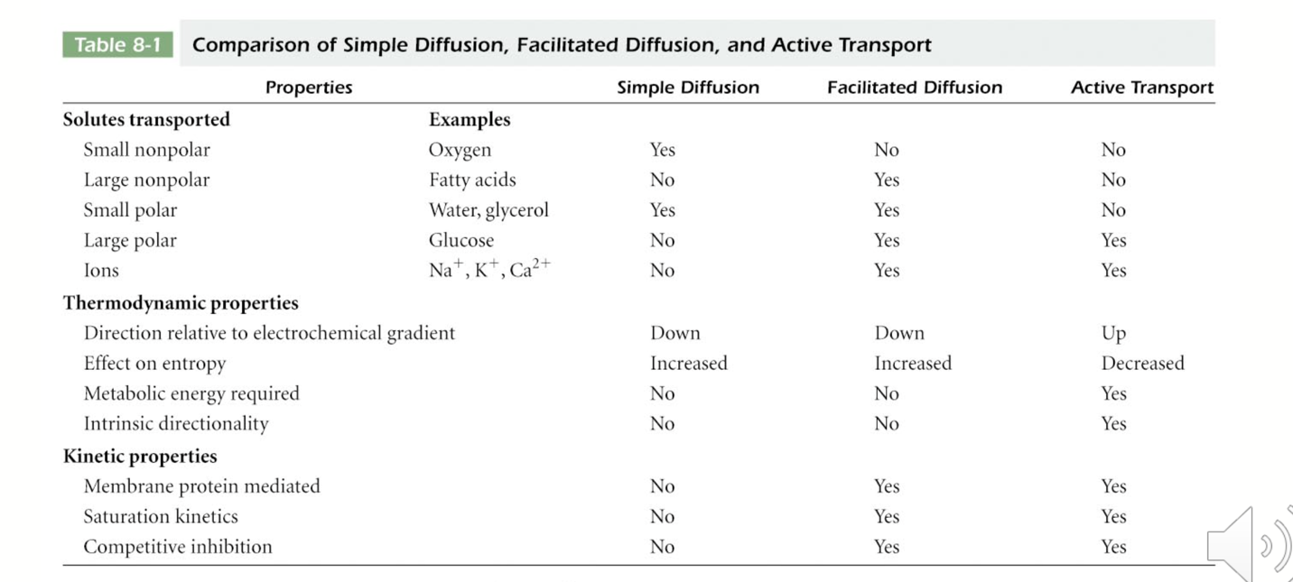

### Rate of simple diffusion directly proportional to concentration gradient

* Simple diffusion thermodynamically always an **exergonic process** (no energy required)
* Simple diffusion is **a linear relationship** between the inward flux of the solute across the membrane and the concentration gradient of the solute, with **no saturation at high concentrations**.

### Facilitated diffusion: protein-mediated movement down the gradient

* **Facilitated diffusion is subject to saturation and follows Michaelis-Menten kinetics**.
* **Facilitated diffusion** **or passive transport** does not require energy, **process is exergonic**:
* Example movement of glucose across the plasma membrane of an erythrocyte. Concentration of glucose is higher in blood plasma than in erythrocytes, so transport of glucose across the plasma membrane is passive.

### Carrier and channel proteins facilitate transport by different mechanisms

* Channel proteins form **hydrophilic channels** through the membrane.
  + **Pores**: large and nonspecific channels. Formed by transmembrane proteins called **porins**, allow molecules weight up to about 600Da to diffuse across the membrane.
  + Most channels are small and highly selective: **ion channels** – **more rapid** no need for a protein to change its shape and capture a solute.
* Carrier proteins are called **permeases**.
  + Like enzymes very specific.
  + Carrier proteins differ in number of salutes transported (**uniport**), and the direction in which they move.
  + Glucose carrier protein is a **uniporter**.
* When two solutes are transported simultaneously and their transport coupled: **co-transport**.
* Same direction: **symport** – opposite direction: **antiport**.

### Glucose transporter: a uniport carrier

* The erythrocyte is capable of glucose uptake by facilitated diffusion, in erythrocyte: GluT1 (glucose transporter).
* GluT1 provides a hydrophilic channel for n-glucose molecules alternating between T1 and T2 conformations.

### Active transport: protein-mediated movement up the gradient.

* Always moves solutes away from thermodynamic equilibrium (up a concentration or electrochemical gradient), therefore always requires energy (ATP -> ADP).
* Process **endergonic**, occurs only when coupled to an exergonic process.
* Performs 3 major functions:

1. Makes possible the uptake of essential nutrients from environment or surroundings of the cell.
2. Allowed secretory products and waste materials to be removed from the cell or organelles.
3. Enables the cell to maintain constant, non-equilibrium intracellular concentration of specific ions: K+, Na+, Ca2+, H+.

### Pumps

* Membrane proteins involved in active transport.
* Passive transport: inherently nondirectional w.r.t membrane. Active transport has **directionality: unidirectional or vectorial process**.
* **Direct or primary active transport**: coupled to an exergonic chemical reaction, most commonly hydrolysis of ATP.
* **Indirect or secondary active transport**: driven by the co-transport of cations-protons down the electrochemical gradient: exergonic inward movement of protons provides energy to move the solute against its concentration gradient.

### Na+/K+ pump

* Uses ATP for energy, example of a transport ATPase.
* Directional: 2 K+ in, 3 Na+ out.
* E1, E2 conformational changes.

# Module 8 - DNA, Chromosomes, the Nucleus

## Information and DNA

* **Replication**: 2 DNA copies are distributed to daughter cells when cell divides.
* **DNA replication**: DNA synthesis.
* **Mitosis**: cell division.
* **Transcription**: involves the use of selected segments of DNA as templates for the synthesis of mRNA and other RNA molecules.
* **Translation**: amino acids are joined in a sequence dictated by the sequence of nucleotides in mRNA. protein synthesis (cytoplasm).
* **Expression of genetic information**: transcription and translation.

## DNA

* Helix is right-handed.
* Contains 10 nucleotide pairs per turn and advances 0.34nm per nucleotide pair.
* Each complete turn of the helix adds 3.4nm to the length of the molecule.
* Diameter of helix: 2nm.
* Pyrimidine-Purine pairing.
* Two chains of DNA complementary to each other.
* Two chains create a **major groove** and **minor groove** which play significant roles in the interactions of variety of molecules.
* **Antiparallel orientation** of the two DNA strands.
* Nucleotides linked by **phosphodiester bonds**.
* **5’-3’ orientation- 3’-5’ in opposite strand**: 5’ carbon linked to 3’ carbon.
* **Supercoiled DNA**: DNA double helix twisted upon itself.
* **Circular DNA** molecules are **negatively supercoiled**.
* Raise temperature to denature DNA: **DNA melting temperature** TM.
* G-C: 3 H2 bonds, A-T: 2 H2 bonds.
* **Strand separation** can be readily achieved because the two DNA strands are bound together by relatively **weak, non-covalent bonds**.
* Strand separation is integral part of DNA replication and RNA synthesis, transcription.
* By raising slowly, the temperature: **DNA denaturation happens** (two strands separated), when lowering the temperature, the reverse happens and **is DNA renaturation**.
* Maximum absorption of UV lights **around 260nm**. As strands separate, absorbance of solution increases rapidly.
* Ability to renature nucleic acids forms the basis of **nucleic acid hybridization**.

## DNA in the genome

* Genome of an organism or virus: complete copy of all the genetic information.
* For many viruses or prokaryotes, genome resides in on DNA molecule.
* Eukaryotic cells have a nuclear genome, a mitochondrial genome.
* Nuclear genome consists of multiple DNA molecules.
* Genome size increases with complexity of the organism with exceptions.
* Genome size is less important than the number and identity of functional genes.
* DNA must be efficiently packaged into cells and yet remain accessible to cellular machinery for DNA replication and transcription.

## Restriction Enzymes

* Cut DNA molecules in places where it encounters a specific recognition sequence, called a **restriction site**.
* Cleave DNA into fragments ranging from a few hundred to a few thousand base pairs
* More amenable to manipulation.
* Gel electrophores is the technique used to separate the fragments to each other, their number and lengths.

## The Nucleus

* Site where the chromosomes are localized and replicated and where DNA is transcribed.
* Both the repository of most cell’s genetic information and control center for expression of the information.

There are two types of cell division: **mitosis** and **meiosis**. Most of the time when people refer to “cell division,” they mean mitosis, the process of making new body cells. Meiosis is the type of cell division that creates egg and sperm cells.

# Module 9 – Signal Transduction

## Receptor-Ligand Interactions

### Signal Transduction Mechanisms

* Receptors are located on receiving cells that can be quite distant from the secreting cell.
* Multicellular organisms can control the activities of specialized cells through the release of chemical messengers.
* The ability of the cell to respond to ligand-receptor binding by altering its behavior or gene expression is signal transduction.

### Different Types of Chemical Signals Can Be Received by Cells

* **Endocrine signals:** produced far from the target tissues, which they reach via the circulatory system.
* **Paracrine signals:** are diffusible and act over short range.
* **Juxtacrine signals**: require physical contact between sending and receiving cells.
* **Autocrine signals**: act on same cell that produces them.

### Receptor Binding Involves Specific Interactions Between Ligands and Their Receptor

* Messengers bind to receptors in a highly specific way.
* The binding site (or binding pocket) on the receptor fits the messenger very closely.
* Necessary amino acid side chain, positioned form chemical bonds with the messenger.

### Receptor-ligand interactions

* Binding of a receptor and a ligand resembles binding of an enzyme and its substrate.
* A receptor specific for a certain ligand: **cognate receptor**.
* A receptor bound to its ligand is **occupied**.

### Receptor Affinity

* **Receptor affinity**: relationship between the ligand in solution and the number of receptors occupied.
* **High ligand affinity**: almost all the receptors are occupied at a low concentration of free ligand.
* **Dissociation constant Kd,** [free ligand] needed to produce a state in which half of receptors occupied.
* High ligand affinity ⬄ low Kd.

### Coreceptors

* Receptor-ligand interactions can be affected by coreceptors on the cell surface.
* They help to facilitate receptor-ligand interaction via physical interaction with receptor.
* Sometimes localized in regions like lipid rafts or lipid microdomains.
* **Toll-like receptors**: ways in which a cell recognizes pathogen.
* **HSPGs**: Heparan Sulfate Proteoglycans.

### Receptor Down-regulation

* Cells sense ligand concentration changes rather than fixed concentrations.
* When receptors occupied for prolonged periods, the cells adapt to no longer respond to ligand.
* **Receptor down-regulation:**
  + Cells reduce density of receptors on their cell surface via **receptor-mediated endocytosis.**
  + Cells can adapt to signals by **desensitization** (common method: **phosphorylation**, add. phosphate group to a molecule), alterations to lower receptor affinity for the ligand.

### Agonist and Antagonists

* **Agonists**: drugs that activate the receptor they are bound to.
* **Antagonists**: bind receptors without triggering a change, prevent naturally occurring messenger from activating the receptor.
* It is possible to make synthetic ligands that bind even more tightly or selectively than the real ligand.

### Receptor Binding activates a sequence of signal transduction events within the cell

* When a ligand binds to its cognate receptor it either induces a change in receptor conformation or causes receptors to cluster (coreceptors).
* Once this takes place, a **preprogrammed** sequence of events is initiated inside the cell.
* Cells can be exposed to a multitude of signals at any given moment.
* Cells must **integrate** these signals to produce appropriate responses (i.e., **signal integration**) without under or over responding.
* A single receptor can **activate multiple pathways, or multiple pathways can converge onto the same molecules.**
* **MAP Kinase pathway**: ligands that signal the cell to grow and divide (**mitogen**).
* **MAPKs phosphorylate transcription factors** that enter the nucleus to alter gene expression.

### Signal Amplification

* Very small quantities of ligand often sufficient to elicit responses from target cell.
* At each step in resulting cascade of event, a signaling intermediate stimulates the production of many molecules for next step.
* **Signal amplification:** multiplication of the effects of the signal.
* **Epinephrine**: part of light-fly response system.

## GPCRs And Second Messengers

### Categories of Receptors

Can be classified

* Ligand-gated channel (ion channels that allows neuro-transmitter to pass through).
* Plasma membrane receptors: linked to G proteins or protein kinases.

### G Protein-Linked Receptors

* **G protein-linked receptor** family: ligand binding causes a change in receptor conformation that activates a G protein (guanine-nucleotide binding protein: **GDP and GTP**).
* The G protein then binds a target protein, such as an enzyme or channel protein, altering target’s activity.
* Many Seven-Transmembrane receptors act via G proteins.
* **Opioid receptors:** G-protein-coupled receptor (GCPRs).

### The structure and regulation of G protein-linked receptors

* The receptor forms 7 transmembrane alpha helices connected by alternating cytosolic or extracellular loops.
* Extracellular portion of each receptor has a unique messenger-binding site.

### The structure, activation, and inactivation of G proteins

* G Proteins act like molecular switches: on when bound to guanosine trisphosphate (**GTP**) and off bound to guanosine diphosphate (**GDP**).
* Large **heterotrimeric G proteins** (3 subunits) **and small monomeric G proteins.**
* Heterotrimeric G proteins mediate signal transduction through G protein-linked receptors and have **Gα, Gβ and Gγ subunits.**

### Regulation of G protein-linked receptors

* Important for cells to be able to stop G protein-linked receptors to activate G proteins by:
* Phosphorylation of amino acids in the cytosolic domain by G protein-linked receptor kinases (**GRKs**) which act on activated receptors.
* **Desensitization**, or adaption to a persistent stimulus: e.g**., β-arrestin** binding to the receptor, blocks further G protein-mediated signaling and targets receptor for internalization.

### G protein Inactivation

* G proteins remain active as long the Gα subunit is bound to GTP and separate from the Gβγ subunit.
* Once the Gα subunit has hydrolyzed GTP to GDP, it is re-associates with Gβγ.
* Some Gα subunits are not very efficient at GTP hydrolysis (i.e., turning off) so G protein activity (for GTP hydrolysis) is greatly enhanced by regulators of G-protein-signaling (RGS) proteins.
* Most important G protein function: release or formation of second messenger.

### Cyclic AMP is a second messenger whose production is regulated by some G proteins.

* **Cyclic AMP (cAMP):** formed from cytosolic ATP by adenylyl cyclase, an enzyme anchored in the plasma membrane.
* Enzyme is inactive until bound to activated GSα (by receptor-ligand stimulated acquisition of GTP and release from GSβγ).

### G proteins are active for only a short period of time

* Because G proteins remain active for a very short time, they can respond quickly to changing conditions:
* Once a G protein becomes inactive, adenylyl cyclase stops making new cAMP.
* The cAMP that remains is degraded.
* cAMP very important in many cellular events: main target is protein kinase A (**PKA**).
* PKA phosphorylates a variety of proteins, using ATP as source of phosphate.
* **When cAMP levels are reduced, PKA activation is also reduced: phosphorylation of cytosolic GPCR site slows.**

### Many G Proteins use inositol trisphosphate (IP3) and Diacylglycerol (DAG) as second messenger

### Calcium in signaling

* Ca2+: essential role in regulating a variety of cellular functions.
* Maintained at low concentration levels through calcium ATPases in the plasma membrane and ER; these transport calcium ions out of the cytosol.
* Calcium concentrations can be released by opening calcium channels in plasma membrane as in neuronal signaling.
* Calcium can also be released from storage in ER through IP3 receptor channel.
* Ca2+ fluorescent dyes.

## Protein Kinase-associated receptors

### Protein Kinase-associated receptors

* Important not only as receptors, but also function **as kinases** (**kinases phosphorylate proteins by transferring phosphate groups to them**).
* Function in many important cellular processes.
* Ligand binding stimulate their kinase activities.
* Signaling of **these receptor protein kinases**: transmitted through **protein Kinase-associated receptors.**

### Growth factors often bind protein kinase-associated receptors

For cells to divide they need enough nutrients for growth and signals to stimulate cell growth.

* Cultured cells in vitro will not grow, even with enough nutrients, unless blood serum is provided.
* Messengers in the serum that stimulate growth are called **growth factors.**
* Several growth factors stimulate receptor tyrosine kinases:
  + **Insulin**
  + **Insulin-like growth factor-1**
  + **Fibroblast growth factor**
  + **Epidermal growth factor**
  + **Nerve growth factor**

### Receptor tyrosine kinases aggregate and undergo autophosphorylation

* Many **receptor tyrosine kinases (RTKs)** trigger a chain of events in the cell that culminate in cell growth, proliferation, or specialization.
* **RTKs**: often consist in a single polypeptide chain with one transmembrane segment.
* **Extracellular part of the receptor: ligand-binding domain.**
* **On cytosolic side: tyrosine kinase domain.**

### The activation of receptor tyrosine kinases

* Signal transduction initiated upon ligand binding that causes aggregation of receptor tyrosine kinases.
* In some cases, receptors dimerize upon ligand binding, and phosphorylate each other: **autophosphorylation**.
* Once autophosphorylation of the receptors occurs, the receptors recruit cytosolic proteins like **Ras and MAP kinases.**
* Receptor tyrosine kinases can also activate **phospholipase C,** leading to **production of IP3 and DAG.**
* Signaling components such as those in the Ras pathway are sometimes assembled into large multiprotein complexes that make cascades more efficient.

### Dominant negative mutant receptors are important tools for studying receptor function

* One approach: introduce mutations into the receptor to determine the effect: e.g., **fibroblast growth factors (FGFs) and their receptor tyrosine kinases (FGFRs).**
* **Normal FGFs** undergo autophosphorylation in response to ligand binding.
* Some types of mutant FGFGRs can bind ligands but cannot undergo autophosphorylation.
* These mutant receptors interfere with normal receptor function because they can dimerize w/ normal receptors.
* **Dominant negative mutation:** a mutant that overrides normal function.

### Constitutive mutations

* Some mutations make FGFRs active in signaling, even when not bound to ligand.
* **Mutation constitutively active:** cause receptor to stay switched “on” all the time.

### Disruptions of growth factor signaling can lead to cancer

Some cancers can result from the loss of regulation of growth factor signaling: e.g., **mutation in Ras often associated with cancer.**

Mutations **in EGFR can result in breast cancer, glioblastoma (brain cancer) and fibrosarcoma (bone cancer)**.

Growth factor receptor pathways share common themes

* Ligand binding often results in activation and/or clustering of receptors, followed by a cascade of events, often phosphorylation (addition of a phosphate group).
* **Phosphorylation may be catalyzed by the receptor, or by Janus activated kinase, when activated by a receptor.**

### Hormone signaling

Plants and animals use secreted chemical signals called hormones to coordinate function of cells and tissues over long distances.

### Hormones can be classified by the distance they travel and by their chemical properties

* **Endocrine hormones**: travel from sending to receiving cells via circulatory system.
* Synthesized by: **endocrine tissues** and secreted directly into bloodstream, with a lifespan ranging from few seconds to many hours.
* As they circulate, they encounter their receptors in target tissues.

The cells **in target tissues have hormone-specific receptors** embedded in their plasma membranes (or, in the case of steroid hormones, in their nucleus or cytosol).

### Chemical classification of endocrine hormones

Endocrine hormones fall into four categories

* **Amino acid derivatives (e.g., epinephrine),**
* **Peptides (e.g., vasopressin).**
* **Proteins (e.g., insulin).**
* **Lipid-like hormones such as steroids (e.g., testosterone).**

### Control of Glucose metabolism is a good example of endocrine regulation

* **Adrenergic hormones: epinephrine and norepinephrine**, function to put the body on hold and redirect resources to the heart and skeletal muscles in dangerous or stressful situations.
* They bind to a family of G protein-linked receptors, adrenergic receptors, **classified as α- and β-adrenergic receptors.**
* These receptors stimulate different pathways (and have different effects) because they are linked to different G proteins.

### Intracellular effects of adrenergic hormonal control of glycogen degradation

* One effect of adrenergic hormones **is to stimulate the breakdown of glycogen to provide muscle cells with an adequate supply of glucose** (energy).
* The breakdown of glycogen is facilitated by the **enzyme glycogen phosphorylase,** resulting in release of a **glucose-1-phosphate**.
* Glycogen degradation begins when an epinephrine molecule binds to a **β-adrenergic receptor** on a liver or muscle cell.

### Insulin signaling acts through PI 3-kinase to regulate resting glucose levels

Specialized cells in pancreas, the **islets of Langerhans** secrete two peptide hormones that regulate glucose levels.

* **Glucagon:** acts to increase blood glucose through glycogen breakdown.
* **Insulin:** reduces blood glucose levels by stimulating uptake into muscle and adipose cells, and stimulating glycogen synthesis.

### Diabetes

* **Insulin**: is a peptide hormone that has rapid and longer-lasting effects on a variety of cells (compared to adrenergic hormones)
* **Type I diabetes:** is an **autoimmune disorder resulting in loss of insulin -** producing cells in the islets of Langerhans (only 5% of people diagnosed with diabetes have this form). It can be somewhat successfully treated with insulin.
* **Type II diabetes:** appears to result from resistance to insulin and so is not as effectively treated with insulin.

### Steroid hormone receptors act primarily in the nucleus, not the cell surface

* Steroid receptor proteins mediate actions of steroid hormones such **as progesterone, estrogen, testosterone, and glucocorticoids.**
* Steroid hormones **are lipid signaling molecules.**
* The hormone enters the target cell and binds its receptor, triggering a cascade of events that activate (sometimes inhibit) transcription of a set of target genes.
* Can diffuse through the plasma membrane.

# Module 10 – Recombinant Technology

## DNA technology

### The PCR Revolution

* DNA fingerprinting analysis can be used to identify and characterize particular sequences contained in as little as 1 microgram of DNA, the amount in a small drop of blood
* But sometimes even that amount of DNA may not be available. In such cases another method, called the polymerase chain reaction (PCR), can come to the rescue. With PCR, it is possible to rapidly replicate, or amplify, selected DNA segments that are initially present in extremely small amounts.

### PCR

* The keys to the simplicity of PCR are an unusual DNA polymerase and the fact that synthetic primers can set up a chain reaction that produces an exponentially growing population of specific DNA molecules.
* To carry out PCR, it is usually necessary to know part of the base sequence of the DNA segment that one wishes to amplify. Based on this information, short single-stranded DNA primers are chemically synthesized; these primers are generally 15-20 nucleotides long and consist of sequences that are complementary to sequences located at the two ends of the DNA segment being amplified.
* DNA polymerase is then added to catalyze the synthesis of complementary DNA strands using the two primers as starting points.
* Thermus aquaticus, an inhabitant of thermal hot springs where the waters are normally 70-80°C. The optimal temperature for this enzyme, called Taq polymerase, is 72°C, and it is stable at even higher temperatures - a property that made possible the automation of PCR.

### DNA Extraction

* Chemical treatments cause cells and nuclei to burst
* DNA spooling: DNA is inherently sticky, and can be pulled out of the mixture.

### Copying DNA

* PCR: Polymerase Chain Reaction.
* A method of making many copies of a piece of DNA.

### Technologies And Utilities

### Historical Perspective

DNA hybridization (1960s)

Detection of hybrids (methods)

• hydroxyapatite (bone material)  
• radio active labelling  
• enzyme-linked detection

• fluorescent labelling

Fixing sample on solid support

• Southern blots(1970s)  
• Northern blots  
• Dot blots

### Basic Principles

Main novelty DNA chips is scale  
• hundreds or thousands of probes rather than tens

• it cannot be achieved manually

Probes are attached to solid supports  
Robotics are used extensively  
Informatics is a central component at all stages

### Major technologies

* cDNA probes usually produced by PCR, attached to either nylon (cheaper, hold less samples) or glass supports
* **Oligonucleotides** attached to glass support
* **Oligonucleotides** synthesized in situ on silica wafers
* (Affymetrix method)
* Probes attached to tagged beads

### Principal uses of chips

Genome-scale gene expression analysis

• **Differentiation**  
• Responses to environmental factors  
• Disease processes

• Effects of drugs

Detection of sequence variation  
• **Genetic typing**  
• Detection of somatic mutations (e.g., in **oncogenes**)

• **Direct sequencing**

### DNA chips

* Probes are DNA fragments, usually amplified by PCR.
* Probes are deposited on a solid support, either positively charged.
* nylon or glass slide.
* Samples are labeled using fluorescent dyes.
* At least two samples are hybridized to chip.
* Fluorescence at different wavelengths measured by a scanner.

### DNA chip design

**Probe selection**• Non-redundant set of probes  
• Includes genes of interest to project  
• Corresponds to physically available clones

**Chip layout**

•  Grouping of probes by function

•  Correspondence between wells in micro-titre plates and

spots on the chip

### cDNA (complementary DNA) fragments arrays on nylon and glass

**Nylon arrays**• Up to about 1000 probes per filter  
• Use radiolabeled cDNA target  
• Can use phosphor imager or X-ray film

**Glass arrays**

•  Up to about 40,000 probes per slide, or 10,000 per 2cm2 area (limited by arrayer’s capabilities)

•  Use fluorescent targets

•  Require specialized scanner

### Scanning the arrays

**Laser scanners**  
• Excellent spatial resolution  
• Good sensitivity, but can bleach fluorochromes

• Still rather slow

**CCD scanners**• Spatial resolution can be a problem

• Sensitivity easily adjustable (exposure time)

• Faster and cheaper than lasers

In all cases, raw data are images showing fluorescence on surface of chip.

### The Affymetrix approach

* Probes are oligos synthesized in situ using a photolithographic approach
* There are at least 5 oligos per cDNA, plus an equal number of negative controls
* The apparatus requires a fluidics station for hybridization and a special scanner
* Only a single fluorochrome is used per hybridization
* It is a very expensive approach!

# Module 11 – Cell Cycle, Mitosis and DNA Replication

## Mitosis and the Cell Cycle

### The Cell Cycle, DNA Replication and Mitosis

* Cell growth is generally accompanied by cell division, whereby one cell gives rise to 2 new daughter cells.
* All the genetic information in the nucleus must be accurately duplicated and carefully distributed to the daughter cells.
* In doing this a cell passes through a series of stages known as the **cell cycle**.

### Overview of the cell cycle

* Begins when two new cells are formed by division of a parent cell and ends when one of these cells divides again.
* Two copies of each chromosome made during S phase are distributed into daughter cells during M phase.
* **M (Mitosis) phase**: the cells actually divide; nucleus first, followed by cytoplasm.
* **Mitosis: nuclear division; cytokinesis: cytoplasm division**.

### Mitosis is a relatively short part of the cell cycle

* Cells spend very little time in M phase.
* Most of the time spent in interphase, composed of **G1 phase, S phase (when DNA is replicated), and G2 phase.**
* Overall length of the cell cycle **called generation time**; in cultured mammalian cells about 18-24 hours.

### Chromosomes in Mitosis

* At the beginning of mitosis, chromatin folds and condenses to produce visible chromosomes.
* At this part of the cycle, DNA has replicated, so each chromosome is composed of two sister chromatids.
* **The mitotic spindle microtubules** distribute the chromatids to opposite ends of the cell.

### Mitosis is subdivided into Prophase, Prometaphase, Metaphase, Anaphase and Telophase

Mitosis is divided into 5 stages based on changing appearance and behavior of chromosomes.

Events during each stage are directed toward the correct distribution of one copy of each chromosome into daughter nuclei.

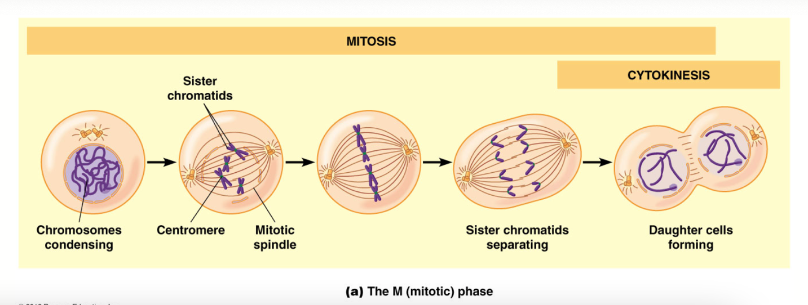

### Prophase

* After DNA replication, cells exit S phase and enter G2 phase, where final preparations are made for entry into mitosis.
* Toward the end of G2, chromosomes begin to condense into more compact, folded structures.
* The G2 -> **prophase** transition is not sharply defined but cells are in prophase when individual chromosomes become visible.
* Centrosomes complete their movement too opposite sides of the nucleus and the spindle MTs contact the condensed chromosomes.
* MTs attach to chromosomes in the **centromere** region.

### Centromere

* DNA in centromeres consists of simple tandemly **repeated CEN sequences**, with considerable variation among species.
* **CENP-A** recruits additional proteins to the centromere to form the **kinetochore**, to which MTs attach.

### Kinetochores

* Kinetochore proteins begin to assemble on centromeres shortly after S phase.
* During prometaphase spindle MTs bind the kinetochores associated with each chromatid.
* Forces exerted by these kinetochore microtubules gradually move chromosomes toward the center of the cells.

### Metaphase

* A cell is in **metaphase** when the fully condensed chromosomes are aligned at the **metaphase plate** (a plane equidistant between the two poles of the spindle).
* Agents that interfere with spindle function (e.g., **colchicine**) are used to arrest cells at metaphase.
* Examining metaphase cells allows chromosome to be id. Generating a **karyotype**.

### Anaphase

* Shortest phase of mitosis.
* Two sister chromatids of each chromosome abruptly separate and move toward opposite poles.
* In **anaphase A,** the chromosomes are pulled toward spindle poles as kinetochore MTs get shorter.
* **In anaphase B,** the spindle poles themselves move away from each other as polar MTs lengthen.

### Telophase

* At the beginning of telophase, daughter chromosomes arrive at the poles of the spindle.
* Chromosomes uncoil into **interphase chromatin**.
* Nucleoli reappear and nuclear envelopes reform.
* During this period, cytokinesis also take place.

### The mitotic spindle is responsible for chromosome movements during mitosis

* **Mitotic spindle:** The microtubule-containing apparatus responsible for separation of chromatids into daughter cells

### Spindle Assembly and Chromosome Attachment

Microtubules have an inherent polarity (the two ends have different chemical properties).

* (-) end: is at the initiating centrosome: end where MT is initiated (the centrosome in the case of the spindle)
* (+) end: points away from the centrosome: where most growth occurs.
* Tubulin subunits are added and removed during mitosis.

### Spindle Assembly

* During late prophase, MT growth speeds up dramatically and initiation of new MTs at centrosomes increases.
* When the nuclear envelope disintegrates, kinetochores and MTs can come into contact.
* When (+) end of MTs and kinetochore bind, the MT becomes **kinetochore MT**.

### So what Drives Chromosomes Movement

* Several motor proteins play active roles in mitosis:
  + Kinesins
  + Dynein
  + Myosin
* The use energy from ATP to change shape and exert force that causes movement of attached proteins.
* Motor proteins play at least 3 distinct roles in movement oof anaphase chromosomes.
  + Move chromosome apart
  + Attach centrosome to plasma membrane
  + Causes spindle to attach

### Cytokinesis Divides the Cytoplasm

* After the chromosomes have separated, cytokinesis divides the cytoplasm in two.
* This usually starts in late anaphase or early telophase.

### Myosin and cleavage

* Contraction of the ring generated by interactions between **actin** and motor protein: **myosin**.
* **Members of Rho-GTP binding proteins** regulate assembly and activation of the contractile ring.
* **RhoA** is recruited to the cleavage furrow to activate proteins needed for actin polymerization and stimulate activation of myosin.

### Cell Division is Sometimes Asymmetric

* Cytokinesis is not always symmetric; sometimes the spindle forms in asymmetric fashion.
* Can result in one large and one small cell.
* Occurs frequently during embryonic development; sometimes cells formed this was have differing developmental potentials.

## DNA Replication

### DNA Replication

Mechanism depends on double-helical structure of DNA.

Semiconservative replication: one strand of every new DNA molecule is derived from the parent molecule and the other is new.

Two parental DNA strands unwind and each specifies a new daughter strand by base-pairing rules.

### DNA Replication is usually bidirectional

* DNA replication is especially well understood in Escherichia coli.
* Replication very similar in prokaryotes and eukaryotes.
* Early biologists studied replication in E. coli; They grew cells in a medium containing 3H-thymidine.
* They visualized the circular chromosomes by autoradiography and observed **replication forks.**
* These are formed where replication begins and then proceeds in *bidirectional fashion* away from the origin

### Eukaryotic DNA Replication involves multiple replicons

* **Replicons**: in eukaryotes replication of linear chromosomes is initiated at multiple sites, creating replication units called replicons.
* **Origin of replication**: at the center of each replicon is a DNA sequence called an origin of replication, where synthesis is initiated by several groups of initiator proteins (a single eukaryotic chromosome may contain several thousand replicons).
* First, a multi-subunit protein complex the **origin recognition complex (ORC) binds** the replication origin.
* Next: the **minichromosome maintenance (MCM)** proteins bind the origin.
* The MCM proteins include **several DNA helicases** that unwind the double helix.
* **Pre-replication complex**: al the DNA-bound proteins bound to this point; the DNA is “licensed” for replication.
* After replication begins, two replication forks synthesize DNA in opposite directions, forming a **replication bubble** that grows as replication proceeds.

### Replication licensing ensures that DNA molecules are duplicated only once prior to each cell division

* Licensing provided by binding of MCM proteins to the origin, which requires both ORC and helicase loaders.
* Ensures that after DNA is replicated at each origin, the DNA cannot be licensed for replication again until after mitosis.
* After replication begins, the MCM proteins are removed from the origins and cannot bind again (**due to Cdk and geminin binding**).

### DNA polymerase catalyze the elongation of DNA chains

* **DNA polymerase**: an enzyme that can copy DNA molecules.
* Incoming nucleotides are added to the 3’ hydroxyl end of the growing DNA chain, so **elongation occurs in the 5’ to 3’ direction**.
* Several forms of DNA polymerase have been identified; the original is now called DNA polymerase I.
* The Directionality of DNA Synthesis: DNA polymerase catalyzes the addition of deoxynucleoside triphosphate (5’ to 3’)

### Biotechnology functions of DNA polymerases

* DNA polymerases have practical applications in biotechnology
* The polymerase chain reaction is a technique in which a DNA polymerase is used to amplify tiny samples of DNA

### DNA is synthesized as discontinuous segments that are joined together by DNA ligase**s**

* DNA is synthesized in the 5’ to 3’ direction, but the two strands of the double helix are oriented in opposite directions.
* **The leading strand** is synthesized in a continuous chain.
* **The lagging strand** is synthesized in discontinuous fragments called **Okasaki fragments**. These are then joined by DNA ligase to form a continuous new 3’ to 5’ DNA strand.

### Proofreading is performed by the 3’->5’ Exonuclease activity of DNA polymerase

* About 1 of every 100,000 nucleotides incorporated during DNA replication is correct.
* Such mistakes fixed by a **proofreading mechanism.**
* Almost all DNA polymerase have a 3’ -> 5’ **exonuclease activity.**
* **Exonucleases** degrade nucleic acids from the ends of the molecules. Exonuclease activity of DNA polymerase allows it to remove incorrectly base-paired nucleotides and incorporate the correct base.
* **Endonucleases** make internal cuts (vital for repair).

### DNA synthesis requires RNA primers

* Natural DNA synthesis (not PCR) is initiated by formation **of short RNA primers.**
* These are synthesized by **primase** using a single DNA strand as the template.

### The process of DNA synthesis

* Once the RNA primer is made, a **DNA polymerase III** adds deoxynucleotides (A’s, C’s, T’s, or G’s) to the 3’ end of the primer.
* **For the leading strand, just one primer is needed, but the lagging strand needs a series of primers to initiate each Okazaki fragment.**
* When the DNA chain reaches the next Okazaki fragment the RNA is degraded and replaced with DNA; adjacent fragments are joined together by DNA ligase.

### Unwinding the DNA double helix requires DNA helicases, Topoisomerases, and single-strand DNA binding proteins

* During DNA replication the two strands of the double helix must unwind at each replication fork.
* 3 classes of proteins facilitate the unwinding:
  + **DNA helicases:** responsible for unwinding the DNA using energy form ATP hydrolysis.
  + **Topoisomerases:** create swivel points in the DNA molecule by making and then quickly sealing double-strand or single-stranded breaks (e.g., **gyrase**).
  + **SSB**: keep the DNA unwound and accessible to the replication machinery.

### Summary: DNA Replication

* Starting at the origin of replication, the machinery at the replication fork adds proteins required for synthesizing DNA.
* These are **DNA helicase, DNA gyrase, SSB, primase, DNA polymerase, and DNA ligase**.
* Several other proteins are used to improve the efficiency, e.g., a ring-shaped sliding clamp keeps DNA polymerase firmly attached to DNA.

### Telomeres solve the DNA end-replication problem

* Linear DNA molecules have a problem completing DNA replication on the lagging strand, because primers are required.
* Each round of replication would end with the loss of some nucleotides from the ends of each linear molecule.
* Eukaryotes solve this problem with telomeres, highly repeated sequences at the ends of chromosomes.

### Telomeres and telomerase

* Human telomeres have 100 to 1500 copies of TTAGGG at the end of chromosomes.
* These noncoding sequences ensure that the cell will not lose important genetic information if DNA molecules shorten during replication.
* **Telomerase:** a polymerase that can catalyze the addition of repeats to chromosome ends (to lengthen the telomere).
* In multicellular organisms, telomerase function restricted to germ cells and few other types of actively proliferating cells.

### Most cells have a limited life span

* Telomere shortening occurs with each cell division in most cells.
* As a result, telomere length is a sort of counting device for how many times a cell has divided; if a cell divides too many times, telomeres could be lost.
* Cells at risk of loss of telomeres undergo **apoptosis**, programmed cell death.

### DNA damage and repair

* DNA must be accurately passed on to daughter cells.
* In addition to ensuring that replication is faithful, this also means that DNA alterations must be repaired.
* DNA alterations, or mutations, can arise spontaneously, or through exposure to environmental agents.

### DNA damage can occur spontaneously or in response to mutagens

* During DNA replication, some types of mutations occur through spontaneous hydrolysis reactions:
  + **Depurination**: loss of a purine base (A or G)
  + **Deamination**: removal of a base’s amino group, changing its base-pairing properties.
* DNA damage can be caused by mutation-causing agents: **mutagens:**
  + Environmental mutagens fall into two categories: chemicals and radiation.
  + Mutagenic chemicals alter DNA structure through a variety of mechanisms.

### **Translesion synthesis** and excision repair correct mutations involving abnormal nucleotides

* A variety of mechanisms are used for DNA repair:
* **Translesion synthesis**: repairs during replication. Involves specialized DNA polymerase.
* Repair endonucleases are recruited to DNA by proteins that recognize damage.
* Excision repair: repairs during DNA replication. Abnormal nucleotides are removed and replaced:
  + *E. coli* has nearly 100 genes that code for proteins involved in this process.
  + Excision repair works by a basic 3-step process:
    - Excision of damaged DNA.
    - DNA polymerization to fill gap.
    - Remaining nick sealed by DNA ligase.

### Progression through the cell cycle is controlled at several key transition points

Control of the cell cycle must:

* Ensure that events of each phase are carried out in correct order and at appropriate time.
* Ensure that each phase is completed before next one begins.
* Respond to external conditions.

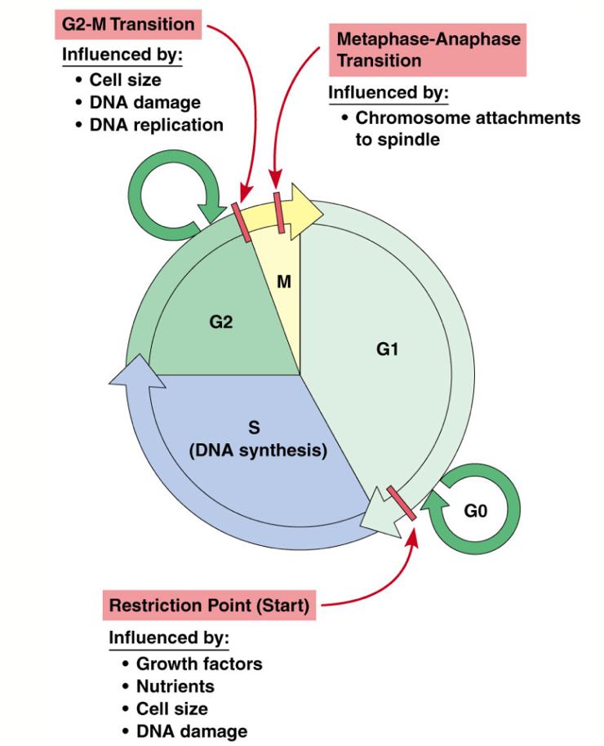

### Checkpoint pathways monitor chromosome-to-spindle attachments, completion of DNA replication, and DNA damage

* If cells proceeded from one phase of the cell cycle to the next without completing each step, daughter cells might be abnormal: e.g., **aneuploidy** (incorrect number of chromosomes) could result.
* Cells use a series of checkpoints that ensure each phase is completed properly before next one begins.

### Checkpoints

* The **mitotic spindle checkpoint** prevents anaphase from beginning before the chromosomes are all attached to the spindle.
* The **DNA replication checkpoint** ensures that DNA synthesis is complete before the cell begins mitosis.

A multiple series of **DNA damage checkpoints** monitor DNA for damage and halt the cell cycle at various points:

* **p53 protein**, **the “guardian of the genome,”** plays a central role in these checkpoint pathways:
  + Regulator of cell cycle, and therefore tumor suppressor.
  + Classified as a “tumor suppressor gene” by Bert Vogelstein at JHMI in 1989.
  + p53 stimulates production of enzymes involved in DNA repair.
  + But if the damage cannot be repaired, p53 activates genes needed to trigger cell death by apoptosis.

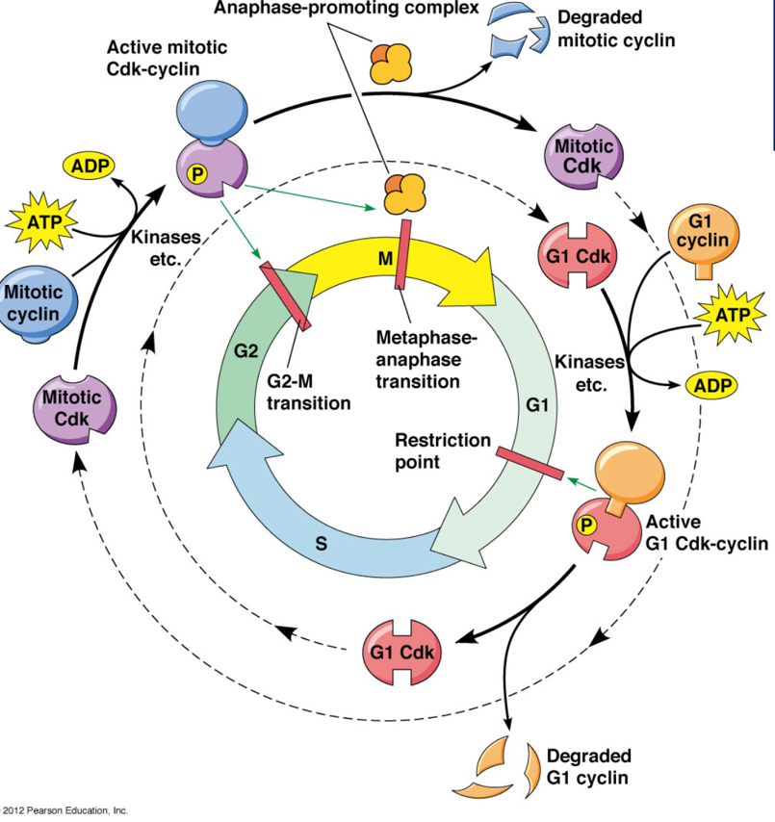

### Apoptosis

* Damaged or diseased cells need to be eliminated.
* In such cases, the process must not damage surrounding cells.
* Multicellular organisms accomplish this through a programmed cell death – **apoptosis**.
* Apoptosis proceeds through the activation of a series of enzymes called **caspases**.

### Necrosis

* Cell death called necrosis sometimes follows tissue injury
* Necrosis involves swelling and rupture of injured cells, whereas apoptosis involves a specific series of events that lead to dismantling of the cell contents

### Apoptosis is triggered by death signals or withdrawal of survival factors

Two main routes by which cells can activate caspases and enter apoptosis:

* Activation can occur directly: e.g., when human cells are infected by viruses**, cytotoxic T lymphocytes** are activated and induce apoptosis.
* When survival factors are withdrawn
  + Site of action is the mitochondrion
  + Healthy cells have **several anti-apoptotic proteins** in outer mitochondrial membrane.

### Damaged cells can trigger their own apoptosis

* If a cell suffers such damage that it can’t repair itself, it may trigger its own demise.
* It can enter apoptosis through the activity of p53.

# Module 12 – Regulation of Gene Expression

## The Regulation of Gene Expression

### Gene regulation

* Gene regulation is an important part of almost every process in nature.
* Most genes are not expressed all the time.
* Selective gene expression enables cells to synthesize only those gene products that are of immediate use.
* In prokaryotes, mechanisms of gene regulation operate mainly at the level of **transcription**.

### Catabolic and anabolic pathways utilize different strategies for adaptive enzyme synthesis

Bacteria use 2 main strategies for regulating enzyme synthesis:

* **Catabolic** (degradative)
* **Anabolic** (synthetic) pathway
* Enzymes that catalyze such pathways are often **regulated coordinately**.

### Catabolic pathways and substrate induction

* **Catabolic enzymes degrade** specific substrates, often to obtain **energy**,
* Catabolic pathway that degrades disaccharide lactose into simple sugars that can be metabolized by glycolysis.
* Hydrolysis of lactose into monosaccharides glucose and galactose is catalyzed by **enzyme β-galactosidase**.
* However, before lactose can by hydrolyzed, it must first be transported into the cell.
* **Galactoside permease** is responsible for this transport, and its synthesis is regulated coordinately with enzyme β-galactosidase.

### Anabolic pathways and end product repression

* Regulation of **anabolic** pathways is the opposite of catabolic pathways.
* Anabolic pathway for synthesizing the amino acid **tryptophan** from starting compound **chorismate**.
* **Chorismate** is an important biochemical intermediate in plants and microorganisms.
* Enzymes that catalyze the 6 steps of this pathway are regulated coordinately at the genetic level.
* For anabolic pathways, the amount of enzyme produced by a cell usually correlates with intracellular concentration of the end-product of the pathway.

### Anabolic pathways and end product repression

* As the concentration of **tryptophan** rises, it is advantageous for the cell to economize on its metabolic resources by reducing its production of the enzymes involved in synthesizing tryptophan.
* It is equally important that the cell be able to turn the production of these enzymes back on when the level of tryptophan decreases again.
* This control is made possible by **the ability of the end-product of an anabolic pathway**. **Tryptophan represses (reduces or stops) further production of the enzymes involved in its formation**
* The reduction in the expression of the enzyme-coding genes is **called end-product repression.**
* Most biosynthetic pathways in bacterial cells are regulated in this way.

### Lac repressor is an allosteric protein whose binding to DNA is controlled by lactose

* A key feature of the operon model is that genes with metabolically related functions are clustered together so their transcription can be regulated as a single unit.
* For induction to occur, an additional gene must be present, a regulatory gene that they named **lacI** (for inducibility).
* Whereas normal bacteria produce, β-galactosidase, galactoside permease and transacetylase only when an inducer is present, deletion of the lacl gene yielded cells that always produce these proteins, even when inducer is absent.
* **The lacl gene codes for a product that normally inhibits, and thereby regulates, expression of the lacZ, lacY, and lacA genes.**
* The regulatory gene product that inhibits expression of other genes is called a **repressor**.

### Genetic repression

* **True genetic repression** always has an effect on protein synthesis.  
  The end products of biosynthetic pathways often have an inhibitory effect on enzyme activity.  
  **Feedback inhibition** differs from repression in both mechanism and result:
* **feedback inhibition**, molecules of enzyme are still present, but their catalytic activity is inhibited.
* **end product repression,** the enzyme molecules are never made.

### Effector Molecules

* One feature common to both induction and repression of enzyme synthesis is **that control is exerted at the gene level in both cases**.
* Control is triggered by small organic molecules called **effectors** present within the cell or the cell's surroundings.
* **Effectors induce shape changes in allosteric proteins that control gene expression**.
* **For catabolic pathways, effectors are almost always substrates** (lactose example) – they function as inducers of gene expression and enzyme synthesis.
* **For anabolic pathways, effectors are usually end products** (example – tryptophan) - they usually lead to the repression of gene expression and repression of enzyme synthesis.

### Genes involved in lactose catabolism are organized into an inducible operon

* Classic example of an inducible enzyme system occurs in the bacterium Escherichia coli.
* It involves a group of enzymes involved in lactose catabolism - the enzymes that catalyze the steps shown in Figure 23-3.
* Much of what we know about the regulation of gene expression in bacteria, including the vocabulary used to express that knowledge is based on the pioneering studies of this system carried out by French molecular geneticists Francois Jacob and Jacques Monod.

### The lac operon

* The lac operon consists of 3 structural genes (**lacZ, lacY, and lacA**) **preceded by a promoter (Plac) and a special nucleotide sequence called the operator (O), which actually overlaps the promoter.**
* **Transcription of the lac operon begins at the promoter,** which is the site of RNA polymerase attachment, and then proceeds through the operator and all the structural genes until finally ending at a terminator sequence.
* The result is a single molecule of mRNA coding for the polypeptide products of all three structural genes. Such mRNA molecules, which code for more than one polypeptide, are called polygenic mRNAs; they occur only in prokaryotic cells.
* Clustering related genes into an operon for transcription into a single polygenic mRNA allows the synthesis of several polypeptides to be controlled in a single step.
* The crucial step in this control is the interaction between an operator site in the DNA and a repressor protein.
* The repressor protein, called **the lac repressor, is encoded by the lacI regulatory gene**, which is located outside the operon (although it happens to be located adjacent to the lac operon it regulates).
* **The lac repressor is a DNA-binding protein that specifically recognizes and binds to the operator site of the lac operon**. When the repressor is bound to the operator (Figure 23-4a), RNA polymerase cannot bind to the promoter and thus transcription of the structural genes is not possible.
* Binding of the repressor to the operator inactivates the operon and keeps its structural genes turned off.

### Repressor protein

* If binding of the repressor to the operator blocks transcription, **how do cells turn on transcription of the lac operon, as occurs in the presence of inducers such as lactose?**
* **Answer - inducer molecules bind to the lac repressor, thereby altering its conformation so that the repressor can no longer bind to the lac operator site in the DNA.**
* **Without repressor bound to it, the operator site is unoccupied and RNA polymerase can bind to the promoter and proceed down the operon, transcribing the lacZ, lacY, and lacA genes into a single polygenic mRNA molecule (**Figure 23-4b).
* A crucial feature of a repressor protein, therefore, is its ability to exist in two forms, only one of which binds to the operator.
* **Repressor: allosteric protein.** It can exist in either of **2 conformational states**, depending whether or not an effector molecule is present: in one state the protein is active; in the other state it is nearly inactive.
* When the effector molecule binds to the protein, it induces a change in the conformational state of the protein and therefore in its activity.
* **The binding is readily reversible, however**, departure of the effector results in the protein’s rapid return to the alternative form.

### Reversible interaction of the lac repressor

* Figure 23-5 shows the reversible interaction of the lac repressor with its effector, called **allolactose, an isomer of lactose produced after lactose enters the cell.**
* The conformational form assumed by the repressor protein in the absence of allolactose recognizes and binds to the operator (**thereby inhibiting transcription), whereas the form with allolactose attached to it does not.**
* The result is that the **repressor protein inhibits transcription of the lac operon in the absence of allolactose, when there is no need to produce the catabolic enzymes encoded by the lac operon.**
* **In the presence of allolactose, the repressor converts to its inactive form, which does not recognize the operator and hence does not prevent transcription of the lac structural genes by RNA polymerase.**
* Lactose triggers the induction of the enzymes encoded by the lac operon. **Because the lac operon is turned off unless induced, it is said to be an inducible operon.**

### The genes involved in tryptophan synthesis are organized into a repressible operon

* Although much of the work leading to the initial formulation of the operon concept involved the lac operon of E. coli, a number of other bacterial regulatory systems are now known to follow the same general pattern, that is, **genes coding for enzymes of a given metabolic pathway are clustered together in a group that serves as a unit of both transcription and regulation.**
* One or more operators, promoters, and regulatory genes are usually involved, although there is **sufficient variation from one operon to another to preclude many generalizations.**
* **Operons coding for enzymes involved in catabolic pathways generally resemble the lac operon in being inducible; that is, they are turned on by a specific allosteric effector, usually the substrate for the pathway involved.**
* **In contrast, operons that regulate enzymes involved in anabolic (biosynthetic) pathways are repressible operons; they are turned off allosterically, usually by an effector that is the end-product of the pathway. The tryptophan (trp) operon is a good example of a repressible operon.**
* **The trp operon** contains the structural genes coding for the enzymes that catalyze the reactions involved in tryptophan biosynthesis, as well as the DNA sequences necessary to regulate the production of these enzymes.
* **The effector molecule in this case is the end-product of the biosynthetic pathway, the amino acid tryptophan.**Expression of the enzymes produced by the trp operon is repressed in the presence of tryptophan (**Figure 23-6a**) and de- repressed in its absence (**Figure 23-6b**).  
  Thus, unlike the lac system, the regulatory gene for this operon, called **trpR**, codes for an allosteric repressor protein that is active (binds to operator DNA) when the effector is attached to it and that is inactive in its free form.
* The effector in such systems (in this case, tryptophan) is sometimes referred to as **a co-repressor because it is required, along with the repressor protein, to shut off transcription of the operon**.

### Eukaryotic gene expression is regulated at multiple levels

Gene expression in eukaryotic cells acts at several different levels:

* 5 main levels of control: 1) the genome 2) transcription 3) RNA processing and export from nucleus to cytoplasm 4) translation and 5) post-translational events.
* **Regulatory mechanisms** in the last 3 categories are all examples of post-transcriptional control which encompasses a wide variety of different processes.

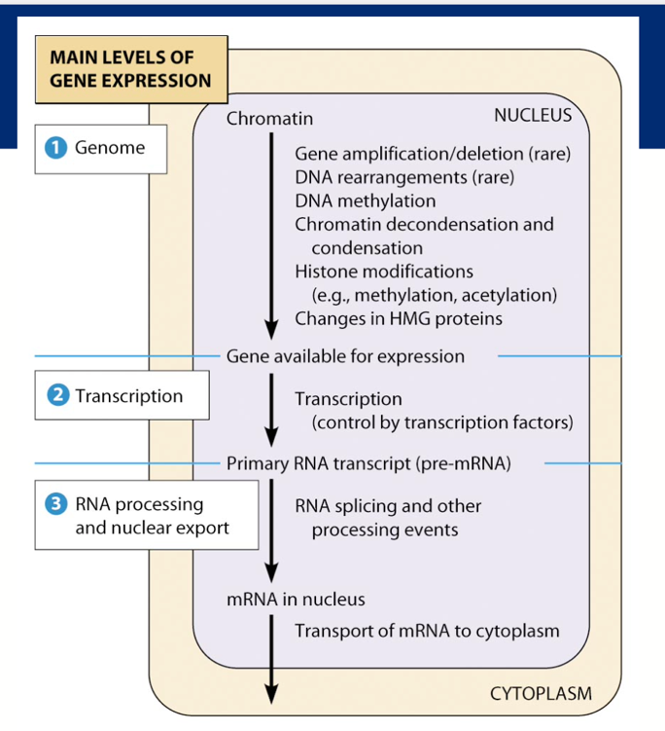

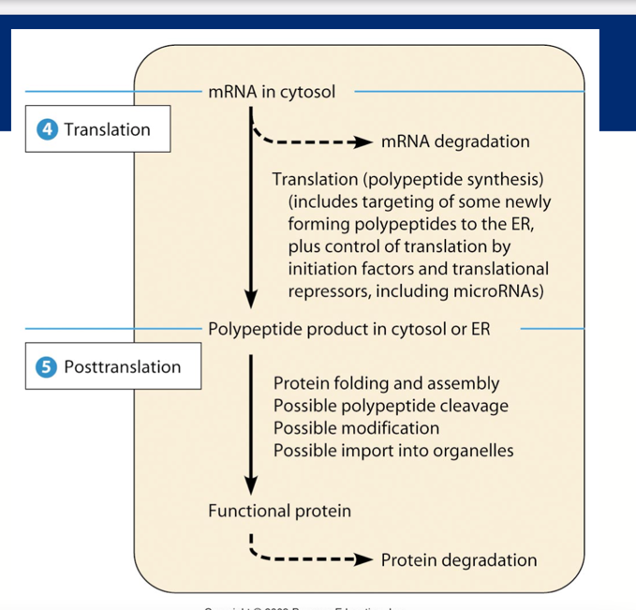

# Module 13 – Gene Expression

## Transcription and Translation

### The central dogma of molecular biology

* DNA => RNA => protein
* **Transcription**: involves copying a gene’s DNA sequence too make an RNA molecule and is carried out by RNA polymerases. Refers to RNA synthesis using DNA as a template.
* **Translation**: converts information in mRNAs into a chain of amino acids linked peptide bonds. It is the synthesis of protein using the information in the **mRNA**, translated into protein.
* There are exceptions to the central dogma:
  + Some RNA viruses carry out **reverse transcription**, using RNA as a template for DNA synthesis.
  + Other viruses produce RNAs from an RNA template.

### Transcription in Eukaryotes and Prokaryotes

* The fundamental principles of transcription were first determined in bacteria, where mechanisms are relatively simple.
* Eukaryotic transcription involves the same four stages as prokaryotic but there are several important differences:
  + Each of 3 different RNA polymerases transcribes one or more classes of RNA.
  + Eukaryotic promoters are more varied than bacterial ones.

### Bacterial Transcription

* Transcription is carried out by the enzyme RNA polymerase, which synthesized RNA using DNA as a template.
* Bacteria have a single kind of RNA polymerase to synthesize all 3 classes of RNA (mRNA, tRNA, and rRNA).
* **The RNA polymerase of. E. coli has two α, two β subunits, and a dissociable σ factor**.

### Transcription involves 4 stages: binding, initiation, elongation, and termination

* The DNA that gives rise to one RNA molecule is called the transcription unit
* Transcription begins when RNA polymerase binds to a promoter sequence (1) triggering local unwinding of the DNA.
* RNA polymerase initiates synthesis of RNA using one DNA strand as a template (2).
* After initiation the RNA polymerase moves along the DNA template, unwinding the helix and elongating the RNA (3).
* Eventually the enzyme transcribes a termination signal which stops RNA synthesis and causes release of the RNA and dissociation of the polymerase (4).

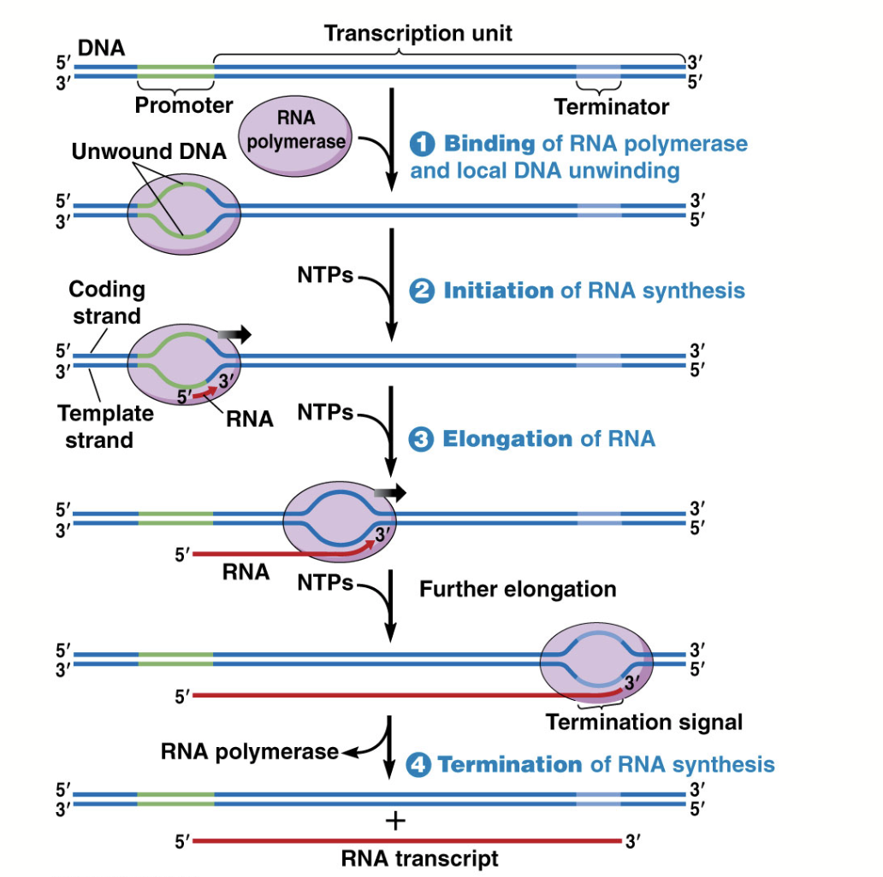

### Eukaryotic transcription

Eukaryotic transcription differs from that of prokaryotes:

* Transcription takes place in the nucleus.
* RNA polymerase in eukaryotes require **transcription factors**.
* RNA cleavage is more important than termination of transcription in determining the 3’ end of the transcript.
* Newly forming RNA molecules undergo RNA processing, chemical modification during and after transcription.
* mRNAs can then be translated into protein in the cytoplasm.

### Gene expression: protein synthesis and sorting

Questions:

* How are messenger RNAs (mRNAs) translated into polypeptides?
* How do the polypeptides become functional proteins?
* How do these proteins reach the destinations where they carry out their functions?
* mRNAs encode instructions for translation, the process of assembling amino acids into a polypeptide.

### Translation: key players

* **Ribosomes**: carry out the process of polypeptide synthesis.
* **tRNA** molecules align the amino acids in the correct order.
* **Aminoacyl-tRNA synthetases** attach amino acids to their appropriate tRNA molecules.
* **mRNA** molecules encode the amino acid sequence information (A, C, G, U).
* **Protein factors**: facilitate some of the steps of translation.

### The ribosome carries out polypeptide synthesis

* Ribosome orient the mRNA and amino acid-carrying tRNAs so the genetic code can be read accurately; they also catalyze peptide bonds so that amino acids are linked into polypeptides.
* Ribosomes are **riboneucleoprotein** (rRNA + proteins).
* In eukaryotes found: free in the cytoplasm, and bound to ER and the outer nuclear envelope (80S)
* In prokaryotes, the ribosomes are smaller (70S).

### Ribosome structure

* Ribosomes are built from dissociable subunits**, the large and small subunits.**
* Bacterial ribosomes **are sensitive to different inhibitors of protein synthesis and are composed of fewer proteins and smaller and fewer RNA molecules.**

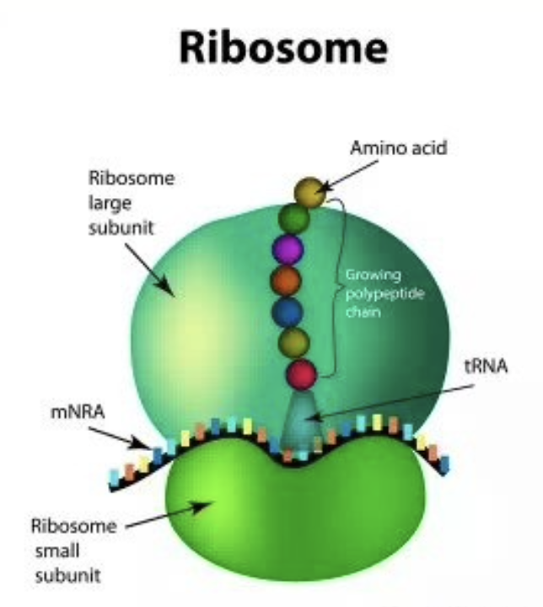

### Ribosomes: antibiotic targets – selective toxicity

Nature Reviews Microbiology 12, 35–48 (2014)  
“Ribosome-targeting antibiotics and mechanisms of bacterial resistance”

<http://www.nature.com/nrmicro/journal/v12/n1/fig_tab/nrmicro3155_F1.html>

### Transfer RNA molecules bring amino acids to the ribosome

* **A tRNA molecule is an adaptor** that has two specific binding sites, one for an amino acid and one for the mRNA sequence that specifies the amino acid.
* Each tRNA is linked to its amino acid by an ester bond.
* tRNA are named for the amino acids attached to the, e.g., tRNAAla for alanine.

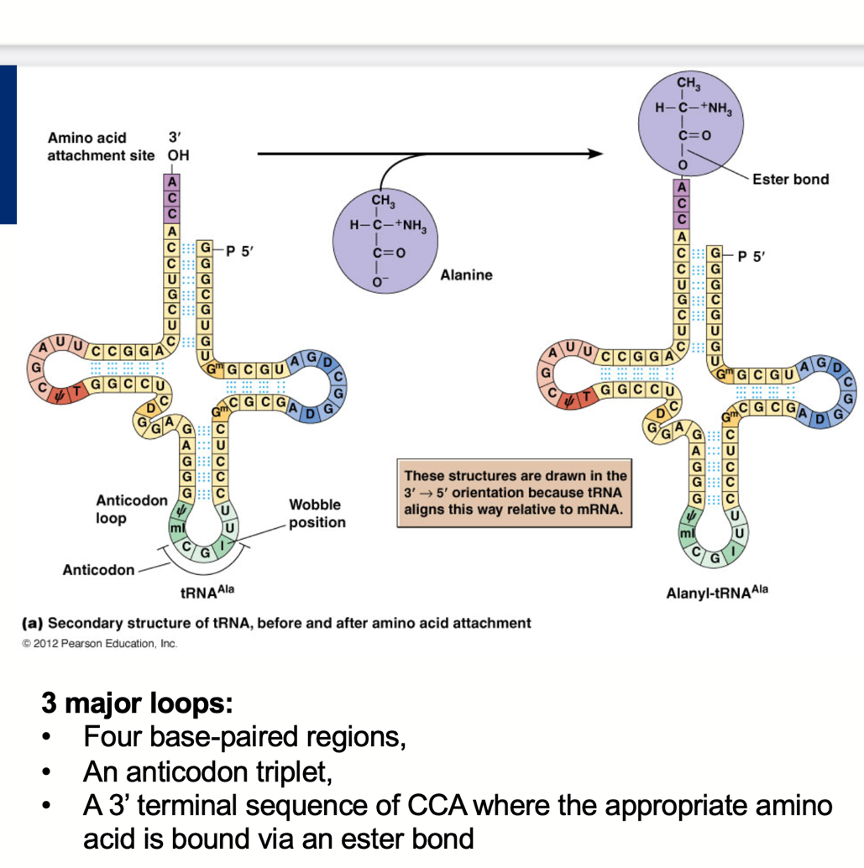

### tRNAs

* **Aminoacyl tRNAs**: tRNAs attached to an amino acid.
* Each tRNA recognizes codons in mRNA due to their complementarity too the anticodon in the tRNA.
* Some tRNA molecules recognize more than one codon.
* mRNA and tRNA line up on the ribosome in a way that permits flexibility or **wobble** in the pairing between the third base of the codon and the corresponding base of the anticodon: wobble hypothesis, which allows for some unexpected pairing.

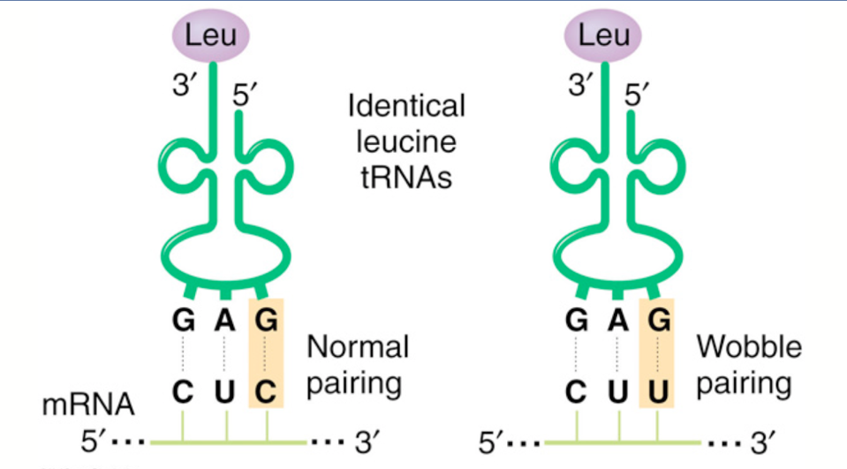

* There may be several different tRNAs capable of pairing with a given codon.
* “Wobble” in the 3rd position allows flexibility, and still results in production of the same amin acid.

### Aminoacyl-tRNA synthetases link amino acids to the correct transfer RNAs

* Before the tRNA can bring its amino acid to the ribosome, the amino acid must be covalently attached to the rRNA by enzymes: **aminoacyl-tRNA synthetases**.
* There one aminoacyl-tRNA synthetase for each amino acid (20): process called **“amino acid activation”.**

### Amynoacyl-tRNA synthesis

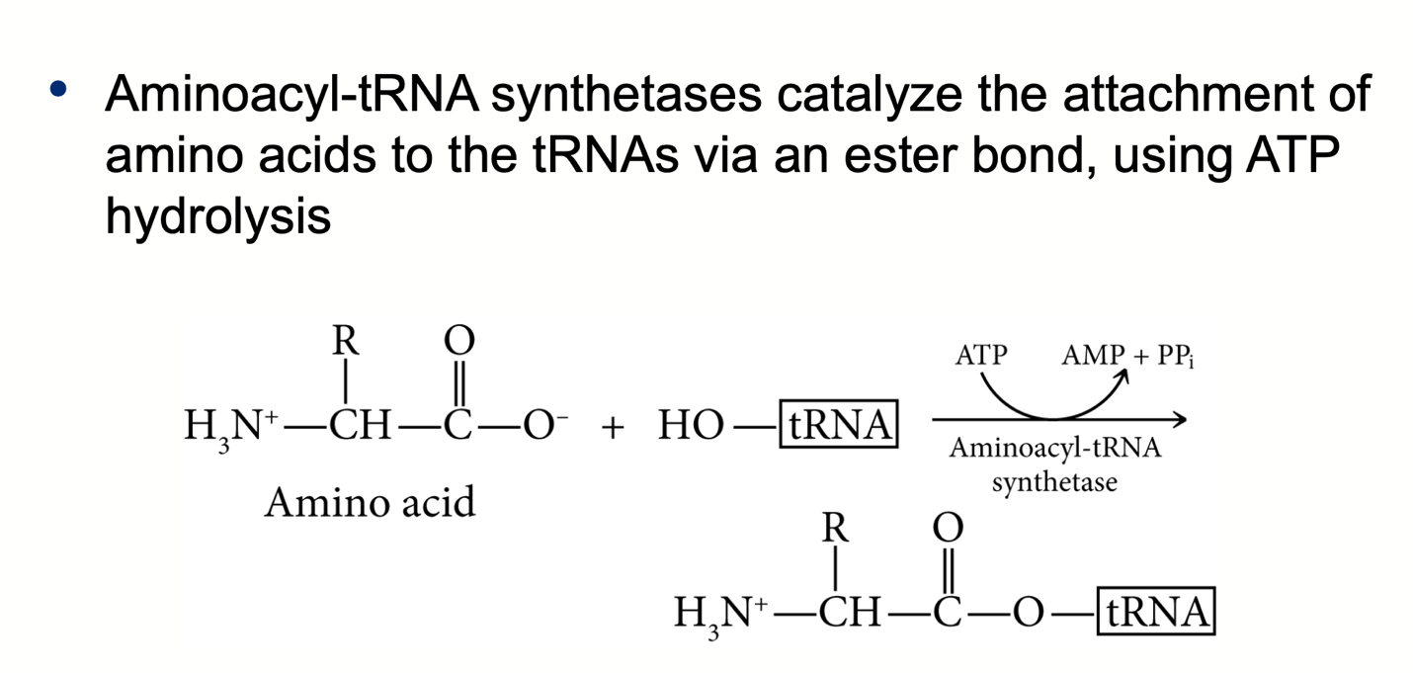

* Both the anticodon and the 3’ end of the tRNA are needed to specify the correct amino acid.
* After addition of an amino acid the synthetases proofreads the final product to ensure the correct amino acid was added.
* It is the tRNA that then recognizes the appropriate codon in mRNA.

### Messenger RNA brings polypeptide coding information to the ribosome

* The sequence of codons in mRNA directs the order of amino acids in the polypeptide.
* mRNA is exported from the nucleus to the cytoplasm via binding to proteins that contain **nuclear export signals (NES);** these proteins target the mRNA through nuclear pores.
* An untranslated sequence at the 5’ end of the message precedes **the start codon, the first to be translated (usually AUG).**
* There is also an untranslated region at the 3’ end of the mRNA that follows the **stop codon, which signals the end of translation.**
* Stop codon may be UAG, UAA, or UGA.
* 5’ and 3’ untranslated regions vary in length and are essential for mRNA function.
* **mRNAs have a 5’ cap and 3’ poly(A) tail within the untranslated region.** The 5’ cap is important for initiating translation in eukaryotes.

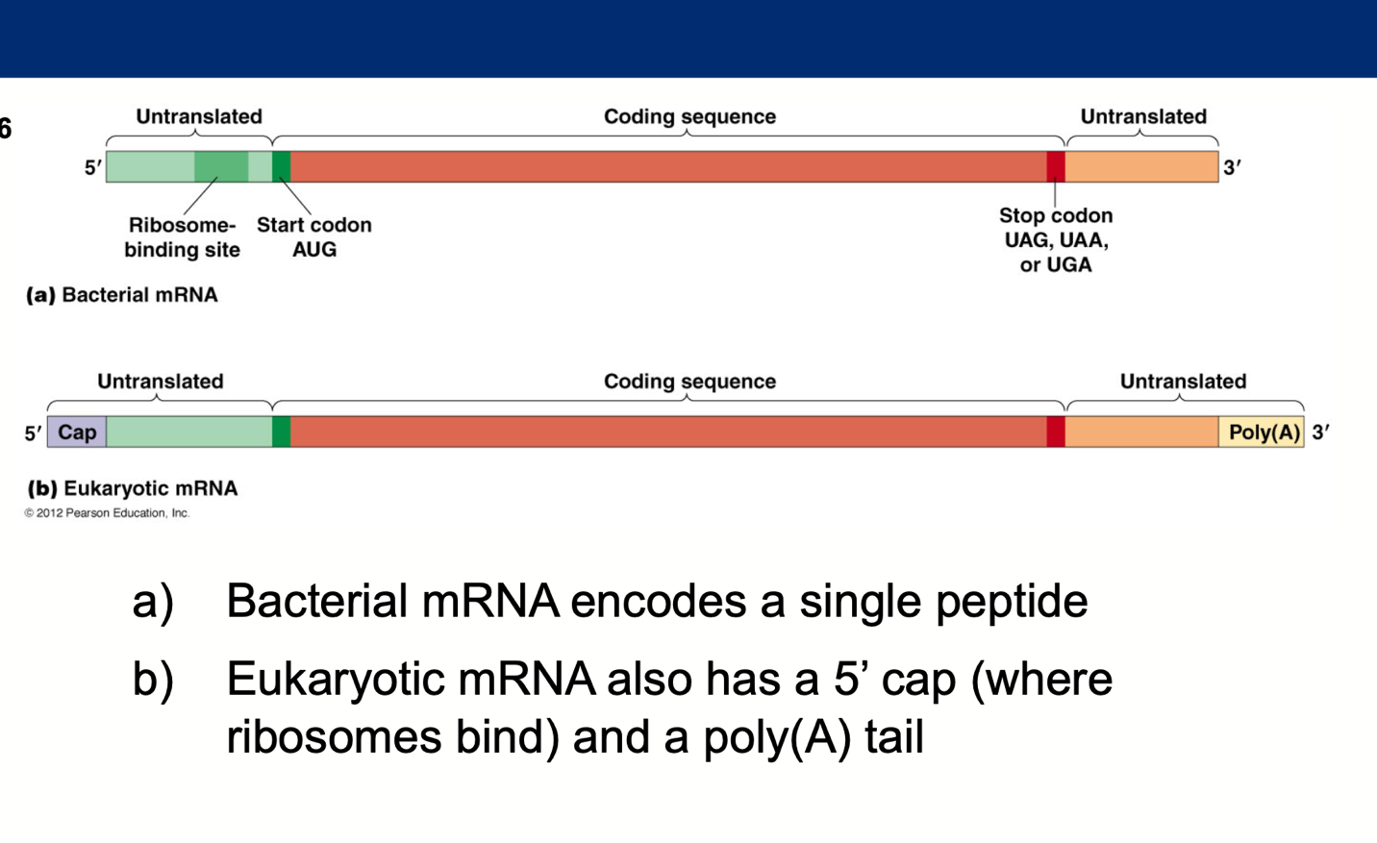

### Eukaryotic mRNAs are monocistronic

* Most (but not all!) mRNAs in eukaryotes are monocistronic, they encode just one polypeptide.
* In bacteria and archaea, some are polycistronic, encoding several polypeptides, usually with related functions.
* These polycistronic transcription units are called **operons**.

### Protein factors are required for the initiation, elongation, and termination of polypeptide chains

Each part of translation requires certain protein factors to:

* *Initiate translation*
* *Elongate the polypeptide chain*
* *Terminate polypeptide synthesis*
* Translation is an ordered, stepwise process that begins at the N- terminus of the polypeptide and adds amino acids to the growing chain until the C-terminus is reached.
* The mRNA is read in the 5’ to 3’ direction.

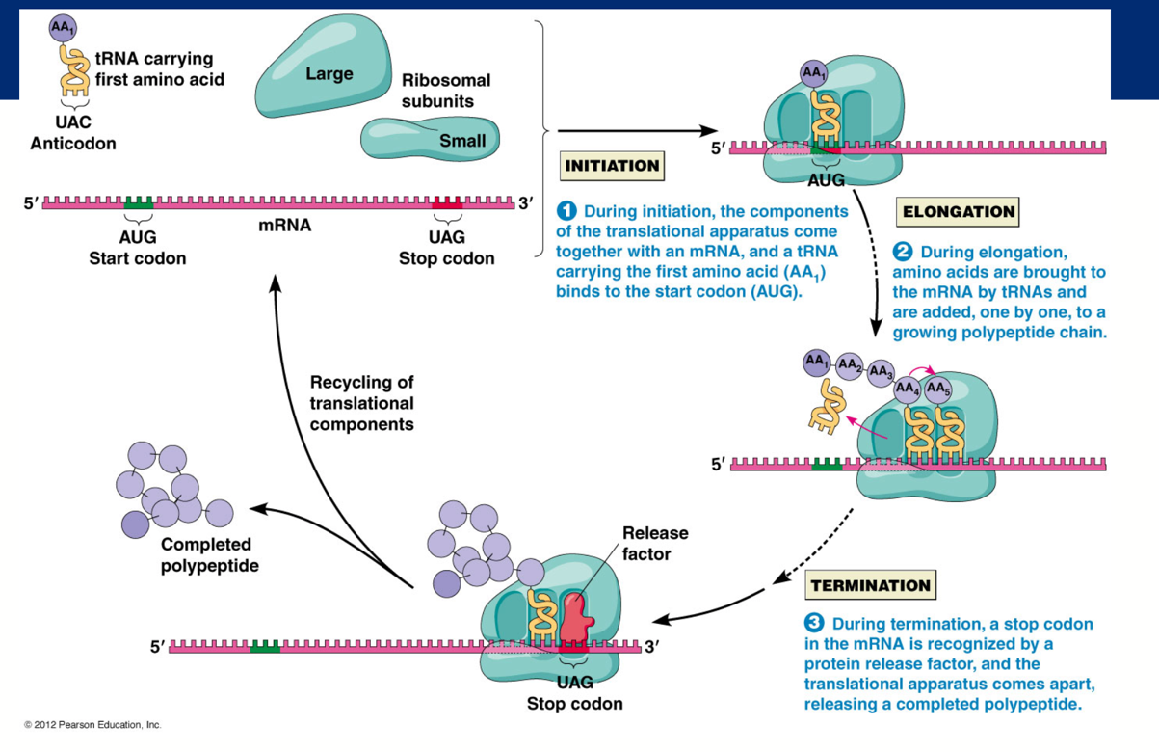

### 

### Initiation of translation in prokaryotes

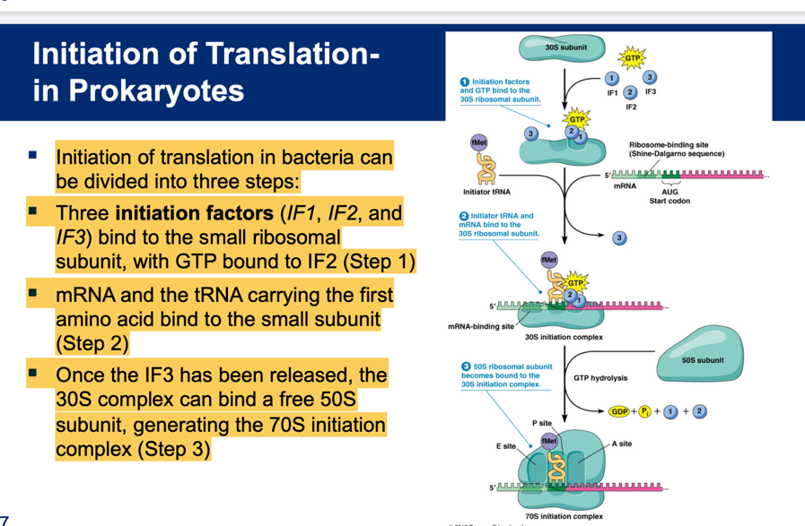

### Eukaryotic initiation

* **The initiation factors bind the tRNA** (these are called **eIFs**; there are about a dozen of these) and the tRNA then binds the small ribosomal subunit.
* The resulting complex then binds to the 5’ end of the mRNA, recognizing the **5’ cap.**
* After binding the mRNA, the small ribosomal subunit (including the initiator tRNA) scans along the transcript and begins translation at the first AUG (st**art codon**).
* After the initiator tRNA is base-paired with the start codon the large subunit joins the complex, facilitated by GTP hydrolysis.

### Chain elongation involves sequential cycles of aminoacyl tRNA binding, peptide bond formation, and translocation

* Once initiation has been completed a polypeptide chain is synthesized.
* Amino acids are added in sequence to the growing chain (**elongation**).
* Elongation involves a repetitive cycle of 3 steps:

1. **Binding of aminoacyl tRNA**

* Elongation begins as a tRNA with an anticodon complementary to the second codon binds the A site (1).
* Elongation factors don’t recognize particular anticodons, so all types (except initiator tRNAs) are brought to the A site.
* Only those with an anticodon complementary to the codon stay at the A site long enough for GTP hydrolysis to take place.
* Mechanisms for selecting against incorrect aminoacyl tRNA synthetases + proofreading result in a final error rate in translation of at most 1/10,000.

1. **Peptide bond formation**

* Once the aminoacyl tRNA is bound to the A site, a peptide bond forms between the amino group of the amino acid at the A site and the carboxyl group of the amino acid at the P site.
* The growing peptide chain is transferred to the tRNA at the A site (2).
* No ATP or GTP hydrolysis is required for this step.
* This step is catalyzed by rRNA.

1. **Translocation**

* After the peptide bond forms, the mRNA advances to bring the next codon into the proper position.
* **During this translocation, the peptidyl tRNA moves from the A to the P site, and the empty tRNA moves to the E site.**
* Once the next mRNA codon reaches the A site, the ribosome is now set to receive the next aminoacyl tRNA.
* The elongation cycle repeats and the amino terminal of the growing polypeptide passes out of the ribosome through an **exit tunnel in the 50S subunit.**
* Here **molecular chaperones** assist its folding.

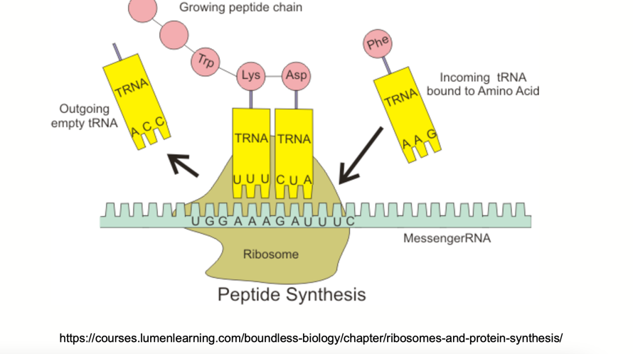

### Termination of polypeptide synthesis is triggered by release factors that recognize stop codons

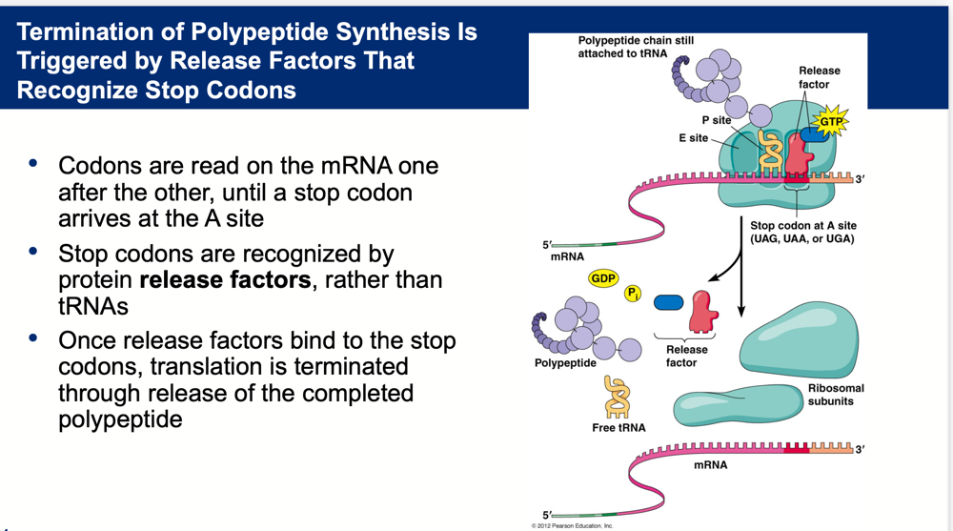

### Polypeptide folding is facilitated by molecular chaperones

* Proteins must fold into their correct 3-D shapes before they can function.
* Protein folding is usually facilitated by proteins called molecular chaperones; often several are required, acting in sequence.
* Chaperones bind polypeptide chains during the early stages of folding.

### Molecular chaperones

* If folding goes awry, chaperones can sometimes rescue the proteins and fold them properly; Alternatively, improperly folded proteins may be destroyed
* Some kinds of incorrectly folded proteins bind to each other and form insoluble aggregates within and between cells (e.g., resulting in diseases like Alzheimer’s disease; mad cow disease).
* Two of the most widely occurring chaperone families **are Hsp70 and Hsp60.**
* Members of each family function differently but both involve ATP-dependent cycles of binding and releasing their protein substrates.
* Chaperones also perform other functions, such as assembling polypeptides into multi-subunit proteins.

### A summary of translation

* Translation converts information in mRNAs into a chain of amino acids linked by peptide bonds.
* Most messages are read by many ribosomes simultaneously.
* RNA molecules play important roles in translation: mRNA, tRNA, rRNA.
* http://www.dnalc.org/resources/3d/16-translation-advanced.html

### Mutations and translation

* mRNAs may contain mutant codons that cause errors in the polypeptide chain synthesized.
* Most codon mutations alter a single amino acid and some (in the third base of a codon) don’t alter the amino acid at all.
* **Mutations that add or remove stop codons or alter the reading frame can severely disrupt translation.**

### Suppressor tRNA overcomes the effects of some mutations

* Mutations that convert amino-coding codons into stop codons, called **nonsense mutations,** typically lead to incomplete, non-functional polypeptides (e.g., cystic fibrosis).
* These mutations are often lethal, but can sometimes be overcome by an independent mutation affecting a tRNA gene.
* A tRNA molecule that negates the effect of a mutation is **called a suppressor tRNA.**
* Suppressor tNRAs recognize stop codons and insert amino acids, suppressing nonsense mutations.

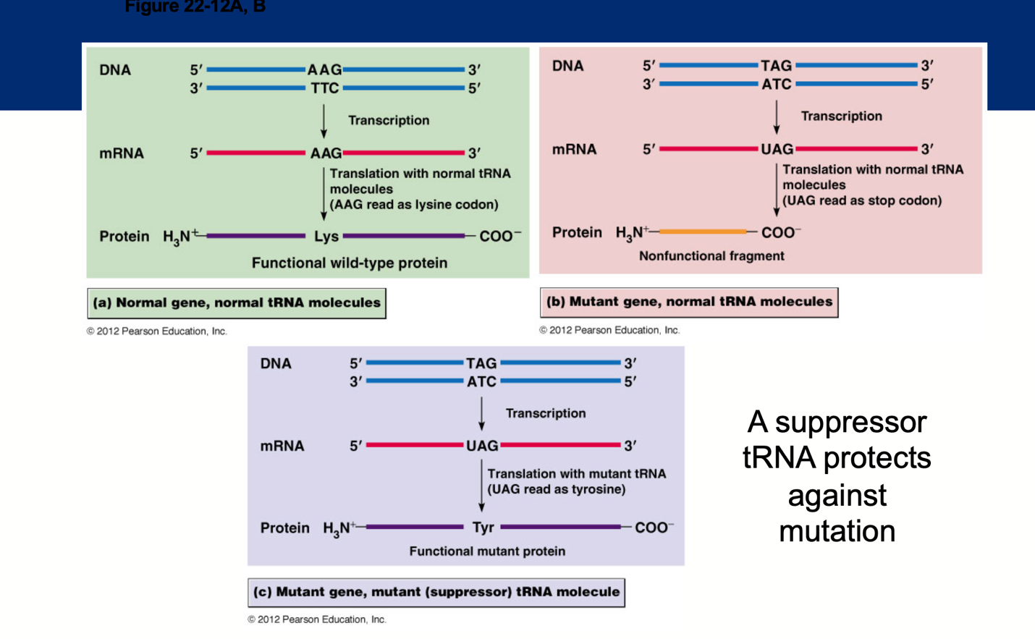

## Post-translational processing and genetic engineering tools

### Posttranslational processing

After polypeptide chains are synthesized, they often must undergo posttranslational modification before they can perform their functions.

* **In bacteria, the N-formyl methionine at the N-terminus is removed.**
* **In eukaryotes, the methionine at the N-terminus is released.**
* Sometimes whole blocks of amino acids are removed from the polypeptide, for instance certain enzymes synthesized as inactive precursors.
* These are activated by removal of sequences from one end of the protein.
* **Transport of proteins across membranes may require removal of a signal sequenc**e and some have internal amino acids that must be removed (e.g., insulin).

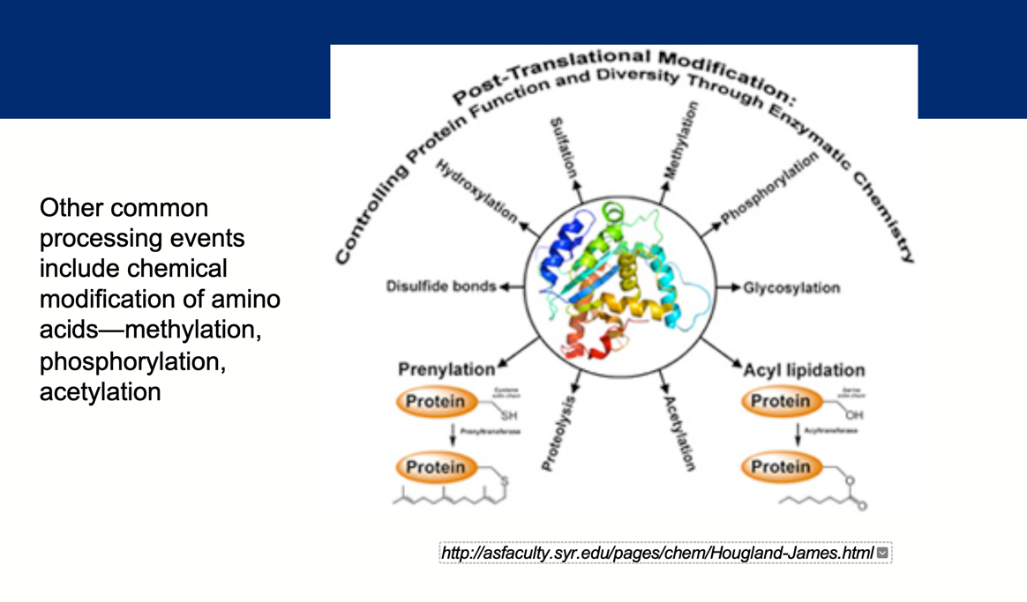

### Translation is mainly cytosolic

* Most polypeptides synthesis (~90%) takes place in the cytosol with transcripts leaving the nucleus through nuclear pores and associating with free ribosomes.
* Shortly after translation begins, 2 pathways for routing the protein products diverge:

### Protein targeting and sorting

* As proteins are synthesized, they must be sorted and directed to their final locations.
* The compartments of eukaryotic cells can be divided into 3 categories:

1. The endomembrane system (ER, Golgi, endosomes, and lysosomes)
2. The cytosol
3. The mitochondria, chloroplasts and peroxisomes and interior of the nucleus.

* Polypeptides are routed to compartments via several mechanisms:
  + Cotranslational transport
  + Signal hypothesis

### Cotranslational import

* The firsts pathway is utilized by ribosomes synthesizing polypeptides destined for the endomembrane system or for export for the cell.
* These ribosomes become attached to ER membranes early in translation, and polypeptide chains are transferred across the ER membrane as synthesis takes place.
* **Cotranslational transport:** movement of the polypeptide across the ER membrane is directly coupled to the translational process (trafficking from the ER to the final destination occurs via vesicles or the Golgi).

### The signal hypothesis

* The signal hypothesis, proposes that proteins that move into the ER during synthesis possess an intrinsic signal, directing them to the ER.
* The **ER signal sequence directs the mRNA polypeptide complex to the rough ER surface**.
* It is now established that only polypeptides with ER signal sequences can be inserted into or across the ER membrane as their synthesis proceeds.
* This has been demonstrated with recombinant DNA methods, where adding a false ER signal sequence results in the polypeptides being directed to the ER.

### Protein folding and quality control take place within the ER

* After polypeptides are released in the ER lumen, they fold into their final shape.
* Protein folding is often accompanied by formation of disulfide bonds.
* Proteins that repeatedly fail to fold properly activate various quality control mechanisms:
  + **Unfolded protein response (UPR),** in which sensor molecules in the ER lumen detect the misfolded proteins.
  + **ER-associated degradation (ERAD) mechanism** recognizes misfolded or unassembled proteins and exports them to the cytosol where they are degraded *proteasomes*.

### Proteins release into the ER lumen are routed to the Golgi complex, secretory vesicles, lysosomes, or back to the ER

* Most proteins synthesized on rough ER are **glycoproteins**.
* The initial glycosylation takes place in the ER as the polypeptide is being synthesized.
* In the Golgi complex, further glycosylation and processing of carbohydrate side chains occurs, and the proteins are sorted and distributed to other locations.

### Soluble proteins

* **Soluble proteins move from the Golgi complex to secretory vesicles for secretion from the cell**.
* Those that are not destined for secretion have specific side chains or signal sequence that target them to destinations within the endomembrane system: e.g., many lysosomal enzymes have side chains with **mannose-6-phosphate.**

### Post-translational import allows some polypeptides to enter organelles after they have been synthesized

* Proteins destined for the nuclear interior, mitochondrion, chloroplast, or peroxisome are imported into these organelles after completion of translation.
* They are synthesized on free ribosomes and released into the cytosol.
* Each protein released to the cytosol has localization signals specific to the destination: e.g., import into the nucleus **require nuclear localization signals** that target proteins for transport through nuclear pores.

### CRISPR/CAS9- What is it and how does it work?

### CRISPR/Cas9 – How is it used as a tool?

### Homologous end joining for gene insertion

### How gene drives could change the world

### Summary

* Posttranslational processing
* Protein sorting and targeting
  + The signal hypothesis
* Genetic Engineering
  + CRISPR/Cas9
  + Gene Drives
* Bioethics